

TY125T-26F

SERVICE MANUAL

# C:\Users\w\Desktop\WPS图片.jpegWPS图片Foreword

This service manual contains the technical data of each component inspection and repair for the TY125T-26F motorcycle. The manual is shown with illustrations and focused on "Service Procedures", “Operation Key Points”, and "Inspection Adjustment" so that provides technician with service guidelines.

If the style and construction of the motorcycle, TY125T-26F, are different from that of the photos, pictures shown in this manual, the actual vehicle shall prevail. Specifications are subject to change without notice.

Zhejiang Tianying Locomotive Co., Ltd.

**I.General information**

01-The main technical parameters……………………… …6

02-Cooling system specifications……………………………7

03-Lubrication system specifications…………………………7

04-Crankshaft, piston and cylinder specifications…………7

05-Cylinder head and valve specifications…………………9

06-Torque value………………………………………………10

07-Electrical device location map……………………………13

08-Service precautions………………………………………14

09-Troubleshooting……………………………………………20

10-Lubrication points…………………………………………24

**II.Maintenance information**

11-Air cleaner………………………...……………………..…25

12-Steering handle top bearing……… ……………..………26

13-Cushion………………………………………….…………26

14-Schematic diagram of the braking system………...……27

14.1-Precautions in operation……………………..………28

14.2-Troubleshooting………………………………………29

14.3-Disc brake system inspection……………….………30

14.4-Add brake fluid………………………………..………31

14.5-Brake fluid replacement / Air-bleed…………………32

14.6-Front brake caliper……………………………………33

14.7-Rear brake caliper……………………………………34

14.8-Brake disk……………………………………………35

14.9-Master cylinder………………………………………35

**III.Engine maintenance**

15-Maintenance information…………………………………38

16-Maintenance standard.….....………………........……...39

16.1-Crankcase breather…......………………….……....40

16.2-Spark plug.....………………….………………........41

16.3-Check and adjust valve clearance.....…................41

16.4-Engine oil............……………………………...........42

16.5-Transmission case oil......………....…...…............44

17-Cooling system maintenance......……….....………......46

17.1-Maintenance information.............…………………48

17.2-Troubleshooting............…………...………….........47

17.3-Cooling system flow pattern diagram..…………...48

17.4-Cooling system: change the coolant..………………49

17.5-Cleaning the radiator storage box……………....…50

17.6-Thermostat parts.........………………………………51

17.7-Water pump parts................…………………………52

17.8-Tee joint.........................……………………………53

17.9-Water temperature sensor.......………….....………54

17.10-Radiator/Cooling Fan.........………………………55

18-Lubrication system maintenance..........….……..........…56

18.1-Maintenance information..........……………………56

18.2-Troubleshooting......................………………………57

18.3-Flow diagram of lubrication system.……...…….....58

18.4-Engine oil pump..............……………………………59

18.5-Engine oil filter.......…………………………………60

19-Cylinder head and valve.....……………………..………61

19.1-Maintenance information.............…………………61

19.2-Troubleshooting...............……………………………63

19.3-Cylinder head component location....……..………64

19.4-Cylinder compression test..........………...…………65

19.5-Cylinder head cover............…………………………66

19.6-Chain tensioner..............……………………………67

19.7-Rocker arms and rocker shafts.......…………...……68

19.8-Camshaft..................…………………………………69

19.9-Timing chain...............................…….....................71

19.10-Cylinder head........................………...................72

19.11-Valve...............................………………...............75

20-CVT system....................................……………...........77

20.1-Maintenance information............……...................77

20.2-Troubleshooting...........…………….......................78

20.3-Component layout...................…………….............78

20.4-Left crankcase case cover............…….................79

20.5-Belt...........................................……........................80

20.6-Main drive pulley parts.............………..................82

20.7-Driven pulley parts....................…………..............84

21-Magneto system maintenance..........…………............87

21.1-Maintenance information..................…..…………87

21.2-Troubleshooting.................…………………………87

21.3-Magneto..................…………………………………88

22-Housing and transmission maintenance....………….…91

22.1-Maintenance information................………………91

22.2-Troubleshooting............……………………………91

22.3-Component location...................……………………92

22.4-Transmission case/Transmission system..………93

22.5-Engine case.....................……………………………95

23-Crankshaft,pistons and blocks…………………………96

23.1-Maintenance information.......………………………96

23.2-Troubleshooting...............……………………………97

23.3-Component layout........................……....................98

23.4-Cylinder block.............................………..................99

23.5-Piston/Piston ring..............…………..……….........100

1. **General information**

**01-Main technical parameters：**

|  |  |  |  |
| --- | --- | --- | --- |
| **Item** | **Technical parameters** | **Item** | **Technical parameters** |
| L×W×Hmm | 1965×730×1180 | Engine type | KS125、4 stroke、forced air cooling、horizontal type |
| Wheelbase mm | 1335 | Transmission type | CVT |
| Front wheel size | 110/80-14 | Transmission ratio | primary:0.81～2.52  secondary :9.857(first order：3.667； second stage ：2.688) |
| Rear wheel size | 130/70-13 | Compression ratio | 11:1 |
| Ground clearance mm | 85 | Bore diameter × stroke mm | 52.4×57.9 |
| Curb weight kg | 139 | Working volume ml | 124.9 |
| Max load kg | 150 | Clutch type | CVT infinitely variable speed |
| Handlebar swivel angleº | ≤48 | Lubrication method | Pressure, pressure splash combined |
| Max speed km/h | ≥100 | Idling r/min | 1700±150 |
| Economic fuel consumption | 367g/kW.h | Crankcase lubricating oil volume L | 0.9 |
| Climbing performance º | ≥16 | Lubricant grade | SF grade 10W/40（crankcase） |
| Battery | 12v/7ah | Ignition method | ECU Electronically controlled ignition |
| Fuel grade | Above RQ92 | transmission case oil volume L | 0.2 |
| Spark plug specifications | CPR8EA-9 | Gear oil grade | SAE 80W/90 |
| Spark plug gap | 0.8～1mm | Fuse | 15 A |
| Gasoline volume L | 11 | Headlamps  (High Beam) | LEDs×2 12V 14.5W |
| Front position light | LEDs×13 12V 2W | Headlamp  (Low Beam) | LEDs×1 12V 6W |
| Front turn signal | LEDs×7 12V 2W | Rear license plate lights | LEDs×3 12V 0.24W |
| Rear turn signal | LEDs×1 12V 0.3W | Brake (brake) light | LEDs×6 12V 1.5W |
| Rear tail light | LEDs×12 12V 1.5W |

**02-Cooling system specifications:**

|  |  |  |
| --- | --- | --- |
| **Item** | | **Technical parameters** |
| Coolant capacity | Radiators and engines | 0.45~0.47 L |
| Water tank | / |
| Radiator cap relief pressure | | (98～110)kpa |
| Thermostat | Start to turn on the temperature | (80～84)℃ |
| Full open temperature | (90～94)℃ |
| Valve lift | 7mm |
| Coolant recommended | | Alcohol-free, silicate-free coolant |
| Standard coolant concentration | | Mix 1:1 with distilled water |

**03**-**Lubrication system specifications:** unit: mm

|  |  |  |  |
| --- | --- | --- | --- |
| **Item** | | **Standard value** | **Maintenance threshold** |
| Engine oil capacity | change engine oil | 0.8 L | - |
| after removing the engine | 0.9 L | - |
| 80W-90 Gear Oil | change gear oil | 0.12 L | - |
| after removing the engine | 0.2 L | - |
| Recommended engine oil | | Recommended engine oil: SF15W-40  API Quality Grade: SG or higher (do not use oils marked as energy efficient on the circular API service label) | - |
| Engine oil pump rotor | Tip clearance | Not more than 0.15 (between inner and outer rotors) | 0.16 |
| Intermediate gap | 0.016～0.074 (inner rotor hole and shaft) | 0.084 |
| Gap on both sides | 0.06 to 0.12 (up and down direction) | 0.13 |

**04**-**Crankshaft, piston and cylinder specifications:** unit: mm

|  |  |  |  |  |
| --- | --- | --- | --- | --- |
| **Item** | | | **Standard value** | **Maintenance threshold** |
| Crankshaft | Large end side clearance of connecting rod | | 0.10～0.35 | 0.45 |
| Clearance between connecting rod big end bearing bush and crank pin | | 0.097～0.127 | 0.07 |
| Beat | | - | 0.05 |
| Cylinder block | Bore | | 52.400～52.410 | 52.500 |
| Out-of-roundness | | - | 0.05 |
| Taper | | - | 0.05 |
| Flatness | | - | 0.05 |
| Pistons, Piston Pins, Piston Rings | Piston base circle diameter | | 52.370～52.390 | 52.30 |
| Pin hole diameter | | 15.002～15.008 | 15.04 |
| Piston pin diameter | | 14.994～15.000 | 14.96 |
| Piston to Piston Pin Clearance | | 0.002～0.014 | 0.02 |
| Piston ring closed gap | First ring | 0.10～0.30 | 0.35 |
| Second ring | 0.20～0.40 | 0.45 |
| Oil ring (scraper ring) | 0.20～0.70 | 0.9 |
| Piston ring and ring groove clearance | Clearance between first ring and groove | 0.020～0.060 | / |
| Gap between second ring and groove | 0.020～0.060 | / |
| Cylinder clearance | | | 0.010～0.045 | 0.10 |
| Inner diameter of connecting rod small end | | | 15.016～15.034 | 15.06 |
| Fitting clearance between connecting rod and pin | | | 0.016～0.040 | 0.06 |

**05**-**Cylinder head and valve specifications：** unit: mm

|  |  |  |  |  |
| --- | --- | --- | --- | --- |
| **Item** | | | **Standard value** | **Maintenance threshold** |
| Electric start cylinder pressure | | | (800～1200)kPa | **-** |
| Valve clearance | | Intake valve | 0.08～0.12 | **-** |
| Exhaust valve | 0.12～0.16 | **-** |
| Rocker arm, rocker arm shaft | Rocker arm inner diameter | Intake/exhaust | 10～10.015 | 10.10 |
| Rocker bearing outer diameter | Intake/exhaust | 9.972～9.987 | 9.91 |
| Rocker arm and bearing | Intake/exhaust | -0.012～-0.032 | -0.008 |
| Gap | Intake/exhaust | 10.013～10.031 | 10.041 |
| Rocker bearing inner diameter | Intake/exhaust | 9.978～9.988 | 9.962 |
| rocker shaft outer diameter | Intake/exhaust | 0.026～0.059 | 0.079 |
| Camshaft | Camshaft hull height | Intake | 29.435～29.555 | 29.39 |
| Exhaust | 29.140～29.260 | 29.10 |
| Bearing and bore clearance | | 0.002～0.026 | 0.036 |
| Beat | | **-** | **-** |
| Valve/vale catheter | Valve stem diameter | Intake | 4.975～4.99 | 4.965 |
| Exhaust | 4.955～4.97 | 4.945 |
| Valve guide inner diameter | Intake/exhaust | 5～5.012 | 5.022 |
| Valve stem to valveduct gap | Intake | 0.01～0.037 | 0.057 |
| Exhaust | 0.03～0.057 | 0.077 |
| Catheter height (leakage) | Intake/exhaust | 10.8～11.2 | **-** |
| Catheter height (drain | Intake/exhaust | 1.0～1.2 | 1.6 |
| Valve spring free length | | Outside the spring | 38.0 | 37.0 |
| inner spring | 35.5 | 34.5 |
| Cylinder head flatness | | 0.05 | | 0.05 |

**06**-**Torque values：**

The torque values listed in below are for more important tightening torque values. Please see standard values for those not listed in the table.

**Standard torque values for reference**

|  |  |  |  |
| --- | --- | --- | --- |
| **Type** | **Tighten torque** | **Type** | **Tighten torque** |
| 5 mm bolt、nut | 0.45~0.6kgf.m | 5 mm screw | 0.35~0.5kgf.m |
| 6 mm bolt、nut | 0.8~1.2kgf.m | 6 mm screw、SH nut | 0.7~ 1.1kgf.m |
| 8 mm bolt、nut | 1.8~2.5kgf.m | 6 mm bolt、nut | 1.0 ~1.4kgf.m |
| 10 mm bolt、nut | 3.0~4.0kgf.m | 8 mm bolt、nut | 2.4 ~3.0kgf.m |
| 12 mm bolt、nut | 5.0~6.0kgf.m | 10 mm bolt、nut | 3.5~4.5kgf.m |

**Engine torque value (regular maintenance)**

|  |  |  |  |  |
| --- | --- | --- | --- | --- |
| **Item** | **Quantity** | **Thread diameter mm** | **Torque value N.m** | **Remark** |
| Spark plug | 1 | 10 | 12～15 |  |
| Valve cover | 1 | 30 | 20～25 | Strainer cover |
| Sealing plug | 1 | 12 | 25～30 | Crankcase oil drain bolt |
| Transmission case oil drain bolt | 1 | 8 | 18～22 | With gasket |
| Transmission case refueling bolt | 1 | 8 | 18～22 | With gasket |

**Cooling system**

|  |  |  |  |  |
| --- | --- | --- | --- | --- |
| **Item** | **Quantity** | **Thread diameter mm** | **Torque value N.m** | **Remark** |
| Radiator guard bolts | 3 | 6 | 8～12 |  |
| Radiator bolts | 4 | 6 | 8～12 |  |
| Radiator bracket clip nut | 3 | 6 | 8～12 |  |
| Radiator bracket self-tapping screws | 3 | 4.8 | 2～3 |  |
| Dust cover bolts | 1 | 6 | 8～12 |  |
| Auxiliary water tank protection plate and auxiliary water tank screws | 3 | 5 | Hand tighten |  |
| Fastening bolts for the outer cover of the breathing tank | 3 | 6 | 8～12 |  |
| Water pump mounting bolts | 3 | 6 | 8～12 |  |
| Fan mounting bolts | 3 | 6 | 7～9 | Apply 1262 thread glue |
| Tee pipe bolts | 2 | 6 | 8～12 |  |
| Thermostat mounting bolts | 2 | 6 | 8～12 |  |
| Engine sensor | 1 | 12 | 14～15 | Water temperature sensor |

|  |  |  |  |  |
| --- | --- | --- | --- | --- |
| **Item** | **Quantity** | **Thread diameter mm** | **Torque value N.m** | **Remark** |
| Cylinder head nut | 4 | 8 | 28～32 | Oil on the nut end |
| Camshaft flapper bolt | 1 | 6 | 8～12 |  |
| Valve rocker shaft bolt | 2 | 5 | 5～9 |  |
| Oil and gas separation plate screw | 4 | ST4.2 | 2～3 |  |
| Cylinder head bolts | 4 | 6 | 8～12 |  |
| Cylinder head cover see oil bolt | 1 | 5 | 8～12 |  |
| Tensioner adjusting bolt | 1 | 6 | Hand tighten |  |
| Cylinder connecting bolt | 2 | 6 | 8～12 |  |

**Cylinder head and valve**

**Belt combination**

|  |  |  |  |  |
| --- | --- | --- | --- | --- |
| **Item** | **Quantity** | **Thread diameter mm** | **Torque value N.m** | **Remark** |
| Main drive pulley tightening nut | 1 | 14 | 63～77 | Auxiliary tooling required |
| Driven pulley tightening nut | 1 | 12 | 43～53 | Auxiliary tooling required |
| Left crankcase cover bolts | 10 | 6 | 8～12 |  |

**Magneto**

|  |  |  |  |  |
| --- | --- | --- | --- | --- |
| **Item** | **Quantity** | **Thread diameter mm** | **Torque value N.m** | **Remark** |
| Magneto rotor bolts | 1 | 12 | 80～90 | Apply 1262 thread glue |
| Magneto stator bolts | 3 | 6 | 18～12 |  |
| Hall sensor bolt | 1 | 6 | 7～9 | Apply 1262 thread glue |
| Trigger fixing bolt | 2 | 6 | 8～12 |  |
| Clamping plate bolts | 2 | 6 | 8～12 |  |
| Right crankcase cover bolts | 10 | 6 | 8～12 |  |

**Case and transmission system**

|  |  |  |  |  |
| --- | --- | --- | --- | --- |
| **Item** | **Quantity** | **Thread diameter mm** | **Torque value N.m** | **Remark** |
| Crankcase bolts | 10 | 6 | 8～12 |  |
| Crankcase positioning stud | 4 | 6 | 8～12 |  |
| Transmission case bolts | 7 | 8 | 18～22 |  |
| Pin lock nut | 1 | 8 | 18～22 | transmission case brake drum locating pin |
| Rear brake camshaft limit bolt | 1 | 6 | 8～12 | Rear brake arm |
| Press pin body tightening bolt | 1 | 6 | 8～12 | Timing chain limit plate fastening |
| Fastening bolt for speed sensor | 1 | 6 | 8～12 |  |
| Speed sensor protection board, lower | 2 | 6 | Hand tighten |  |

**Crankshaft, piston,cylinder**

|  |  |  |  |  |
| --- | --- | --- | --- | --- |
| **Item** | **Quantity** | **Thread diameter mm** | **Torque value N.m** | **Remark** |
| Drain bolt | 1 | 6 | 12 | Drain port on cylinder block |

# 07-Electrical device location mapG:\0-TLJ\工作文件\ADV\三业ADV-2代\三业ADV2代KS125维修手册\电器位置-中英文版.jpg电器位置-中英文版:

**08-Service precautions:**

* Always use genuine parts and recommended oil.Using improper parts may cause damage to or

**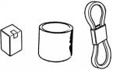** destruction of the vehicle.

* Special tools are designed for removal and installation of component parts without damaging them. Using wrong tools may result in parts damage.

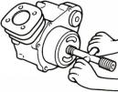

* When servicing this vehicle, use only metric tools. Metric bolts, nuts, and screws are not interchangeable with the Britain system, using wrong tools and fasteners may damage this vehicle.
* Clean the outside of the parts or the cover before removing it from the vehicle. Otherwise, dirt and deposit accumulated on the part's surface may fall into the engine, chassis, or brake

system to cause damage.

* Wash and clean parts with high flash point solvent, and then blow dry with compressed air. Pay special attention to O-rings or oil seals because most of the cleaning agents have bad effect

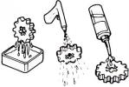on them.

* Never bend or twist control cables to avoid unsmooth control and premature worn out.

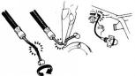

* Rubber parts may become deteriorated when old, and be damaged by solvent and oil easily. Check these parts before installation to make sure that they are in good condition, replace if necessary.
* When loosening a component which has different sized fasteners, operate with a diagonal pattern and work from inside out. Loosen the small fasteners first. If the bigger ones are loosen first, small fasteners may receive too much stress.
* Store complex components such as transmission parts in the proper assemble order and tie them together with a wire for ease of installation later.

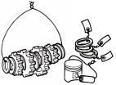

* Note the reassemble position of the important components before disassembling them to ensure they will be reassembled in correct dimensions (depth, distance or position).
* Components not to be reused should be replaced when disassembled including gaskets metal seal rings, O-rings, oil seals, snap rings, and split pins.

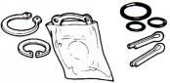

* The length of bolts and screws for assemblies, cover plates or boxes is different from one another, be sure they are correctly installed. In case of confusion, Insert the bolt into the hole to compare its length with other bolts, if its length out side the hole is the same with other bolts, it is a correct bolt. Bolts for the same assembly should have the same length.

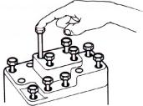

* 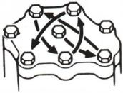Tighten assemblies with different dimension fasteners as follows: Tighten all the fasteners with fingers, then tighten the big ones with special tool first diagonally from inside toward outside, important components should be tightened 2 to 3 times with appropriate increments to avoid warp unless otherwise indicated. Bolts and fasteners should be kept clean and dry. Do not apply oil to the threads.
* When oil seal is installed, fill the groove with grease, install the oil seal with the name of the manufacturer facing outside, and check the shaft on which the oil seal is to be installed for smoothness and for burrs that may damage the oil seal.

**Manufacturer's name**

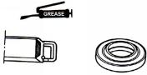

* Remove residues of the old gasket or sealant before reinstallation, grind with a grindstone if the contact surface has any damage.

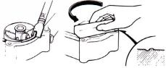

* The ends of rubber hoses (for fuel, vacuum, or coolant) should be pushed as far as they can go to their connections so that there is enough room below the enlarged ends for tightening the clamps.

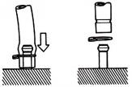

Groove

Clamp

Connector

* Rubber and plastic boots should be properly reinstalled to the original correct positions as designed.

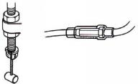

**Boots**

* 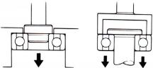The tool should be pressed against two (inner and outer) bearing races when removing a ball bearing. Damage may result if the tool is pressed against only one race (either inner race or outer race). In this case, the bearing should be replaced. To avoid damaging the bearing, use equal force on both races.

**Both of these examples can result in bearing damage.**

* Lubricate the rotation face with specified lubricant on the lubrication points before assembling.



* Check if positions and operation for installed parts is in correct and properly.

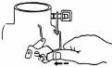

* Make sure service safety each other when conducting by two persons.

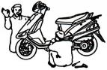

* Note that do not let parts fall down.



* Before battery removal operation, it has to remove the battery negative (-) cable firstly. Notre tools like open-end wrench do not contact with body to prevent from circuit short and create spark.

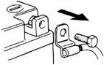

* After service completed, make sure all connection points is secured.Battery positive (+) cable should be connected firstly
* And the two posts of battery have to be greased after connected the cables.

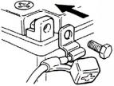

* Make sure that the battery post caps are located in properly after the battery posts had been serviced.

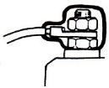

* If fuse burned, it has to find out the cause and solved it. And then replace with specified capacity fuse.

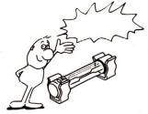

**Capacity verification**

* When separating a connector, it locker has to be unlocked firstly；Then, conduct the service operation.



* Do not pull the wires as removing a connector or wires；Hold the connector body.



* Make sure if the connector pins are bent, extruded or loosen.
* Insert the connector completely.If there are two lockers on two connector sides, make sure the lockers are locked in properly.Check if any wire loose.
* Check if the connector is covered by the twin connector boot completely and secured properly.



* Before terminal connection, check if the boot is crack or the terminal is loose.



* Insert the terminal completely.Check if the terminal is covered by the boot. Do not let boot open facing up.



* Secure wires and wire harnesses to the frame with respective wire bands at the designated locations. Tighten the bands so that only the insulated surfaces contact the wires or wire harnesses.

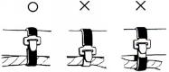

* 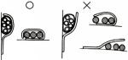Wire band and wire harness have to be clamped secured properly.
* Do not squeeze wires against the weld or its clamp.



* Do not let the wire harness contact with rotating, moving or vibrating components as routing the harness.

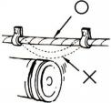

* Keep wire harnesses far away from the hot parts.

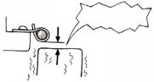

**Never Touch**

* Route wire harnesses to avoid sharp edges or corners and also avoid the projected ends of bolts and screws.

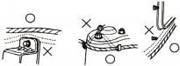

* Route harnesses so that they neither pull too tight nor have excessive slack.

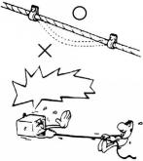

**Never too tight**

* 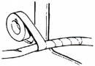Protect wires or wire harnesses with electrical tape or tube if they contact a sharp edge or corner. Thoroughly clean the surface where tape is to be applied.
* 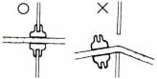Secure the rubber boot firmly as applying it on wire harness.
* Never use wires or harnesses which insulation has been broken.Wrap electrical tape around the damaged parts or replace them.

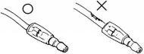

* Never clamp or squeeze the wire harness as installing other components.

**Never clamp or squeeze the wire harness**

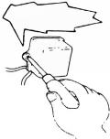

* Do not let the wire harness been twisted as installation.

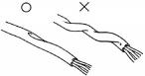

* Wire harnesses routed along the handlebar should not be pulled too tight or have excessive slack, be rubbed against or interfere with adjacent or surrounding parts in all steering positions.

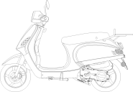

* Before operating a test instrument, operator should read the operation manual of the instrument. And then, conduct test in accordance with the instruction.

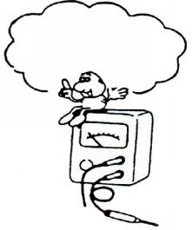

**Do you know how to set the instrument to its measurement position and the insert locations of its two probes?**

* With sand paper to clean rust on connector pins/terminals if found. And then conduct connection operation later

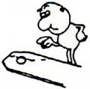

**Clean rust**

**09-Troubleshooting：**

1. **Engine cannot be started or difficult to be started**

**Probable causes**

**Check and adjustment**

**Check and adjustment**

**The fuel supply to the fuel injector is sufficient**

**Press the fuel injector feed pipe and confirm whether there is fuel in the feed pipe**

**The fuel injector is not**

**Check the spark plug ignition condition**

**Week sparks or no spark**

**Sparks**

**Perform cylinder compression pressure test**

**2.Check if the fuel pipe and the vacuum**

**tube are blocked or not**

**cuvavacuumvacuum**

**3.Malfunction of fuel pump relay or wiring**

**5.The fuel strainer is blocked or not**

**4.Malfunction of fuel pump**

**2.Malfunction of throttle valve operation**

**1.Contaminated or clogged fuel injector**

**2.Malfunction of fuel pressure regulator**

**Wet spark plug**

**Dry spark plug**

**1.Malfunction of throttle valve operation**

**3.Incorrect ignition timing**

**2.Air sucked into intake manifold**

**With signs of ignition but the engine cannot be started**

**No ignition**

**5.Ignition coil is in open or short circuit**

**6.Malfunction of main switch**

**4.Malfunction of the AC Generator**

**3.Malfunction of ECU**

**2.Spark plug contamination**

**1.Malfunction of spark plug**

**2.Malfunction of cylinder valves**

**4.Cylinder gasket leakage**

**3.Worn cylinder and piston ring**

**5.Sand hole in the compression parts**

**1.Piston ring seized**

**Low or no compression pressure**

**1.Check the fuel amount in the fuel tank**

**Normal cylinder compression pressure**

**Restart the engine**

**Remove and check the spark plug**

1. **Engine runs sluggish (Speed does not pick up, lack of power)**

**Fault condition**

**Fault condition**

**Accelerate gradually and  
 check engine RPM**

**Check and adjustment**

**1.Clogged air cleaner**



**Normal**

**Continually drive in acceleration or high speed**

**Engine RPM can be increased**

**Abnormal compression pressure**

**3.Poor fuel quality**

**4.Abnormal ignition timing**

**2.Malfunction of fuel injector**

**1.Carbon deposit in the combustion chamber**

**4.Carbon deposit in the combustion chamber**

**3.Poor fuel quality**

**2.Abnormal fuel injector**

**1.Worn out piston or cylinder**

**1.Incorrect spark plug heat range**

**1.Remove the dirt**

**1.Replace the fuel injector**

**4.Valve deterioration**

**3.Sand hole in compression parts**

**5.Jammed piston ring**

**2.Cylinder gasket leakage**

**1.Worn out cylinder or piston ring**

**1.Malfunction of ECU**

**2.Malfunction of AC Generator**

**4.Clogged fuel injector**

**3.Clogged exhaust pipe**

**2.Poor fuel supply**

**No knocking**

**Knocking**

**Check cylinder compression pressure (using compression**

**Engine overheated**

**Check if the engine is over heated**

**No contamination or**

**contamination or**

**Remove and check the spark plug**

**clogged**

**Not clogged**

**Check if the fuel injector is clogged or not**

**Normal compression pressure**

**Incorrect ignition**

**Correct ignition timing**

**Check ignition timing (Using ignition lamp)**

**Engine RPM cannot be increased**

1. **Engine runs sluggish (especially in low speed and idling)**

**Probable causes**

**Fault condition**

**Check and adjustment**

**Check ignition timing (using ignition lamp)**

1. **Incorrect ignition timing**

**(malfunction of ECU or AC）**

**Normal**

**Abnormal**

**Check for any air sucked in through the throttle body insulator gasket**

**1.Abnormal throttle body insulator gasket**

**4.Damaged ABV pipe**

**3.Abnormal inlet pipe gasket**

**2.Abnormal throttle body installation**

**Air sucked in**

**No air sucked in**

**Remove the spark plug and check the spark condition**

**1.Contaminated spark plug**

**3.Malfunction of AC Generator**

**2.Malfunction of ECU**

**4.Malfunction of ignition coil**

**Good spark**

**Poor spark**

**5.Open or short circuit in spark plug leads**



**6.Malfunction of main switch**

**D.Engine runs sluggish (High speed)**



**Fault condition**

**Probable causes**

**Poor**

**Good**

**Check the fuel pump supply condition**

**Check if fuel injector clogged supply condition**

**Clogged**

**Normal**

**1.Replace the fuel injector**

**Abnormal**

**Normal**

**Check ignition timing**

**1.Insufficient fuel in the fuel tank**

**2.Pressed or clogged fuel pipe**

**1.Malfunction of ECU**

**2.Malfunction of AC Generator**

**Check and adjustment**

**E.CLUTCH AND DRIVING PULLEY**

**Engine can be started but the vehicle cannot run**

**FAULT CONDITION**

**PROBABLE CAUSES**

**1.Worn out or damaged drive belt**

**2.Damaged movable drive face**

**3.Damaged driven face spring**

**4.Broken clutch weight**

**5.Broken drive shaft groove**

**6.Worn out or damaged transmission gear**

**1.Broken clutch spring**

**Engine shuts down or trembles when the vehicle is running (rear wheel rotates during engine idling)**

**2.Clutch outer stuck with clutch weights**

**3.Connection parts between clutch and shaft worn out or burned**

**1.Worn or deformed drive belt**

**Poor initial driving (poor climbing performance)**

**2.Worn weight roller**

**3.Worn driven face**

**4.Deformed driven face spring**

**5.Grease on drive belt or drive / driven**

### 10-Lubrication points：

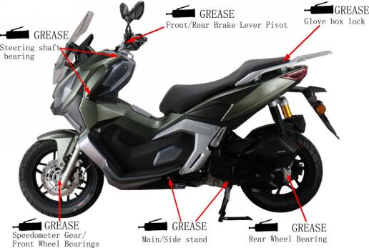

1. **Maintenance Information**

11-Air Cleaner：

1. Remove 8 screws from the air cleaner cover and then remove the cover;

**8 screws**

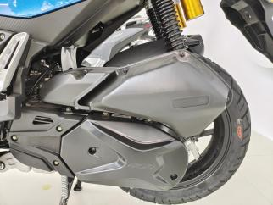

1. Remove the air cleaner element;

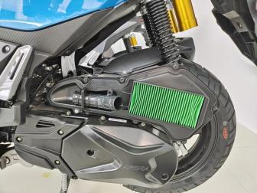

**Air filter element**

3.Clean air cleaner element:

Use compressed air to remove the adhesion of dirt,if too much dirt , please new replacement.



**Caution**

* The air cleaner element is made of paper so do not soap it into water or wash it with water.

### 12-Steering handle top bearing：

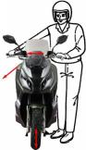

 **Caution**

* Lift the front wheel out of ground；
* Check all wires and cables if they are interfered with the rotation of steering handle bar.
* Turn handle from right to left alternative and check if turning is smoothly；
* If handle turning is uneven and bending, or the handle can be operated in vertical direction, then adjust the handle top bearing。



1. **Cushion：**

 **Caution**

**Front cushion**

* Do not ride the motorcycle with poor cushion.
* Looseness, wear or damage cushion will make poor stability and drive-ability.
* Press down the front cushion for several times to check it operation；
* Check if it is damage Replace relative parts if damage found；
* Tighten all nuts and bolts

**Rear Cushion**

* Press down the front cushion for several times to check it operation；
* Check if it is damage Replace relative parts if damage found；
* Park motorcycle with main stand；
* Turn the rear wheel forcefully and check if engine bracket bushing worn out Replace the bushing if looseness found；
* Tighten all nuts and bolts。

### 14-Schematic diagram of the braking system:

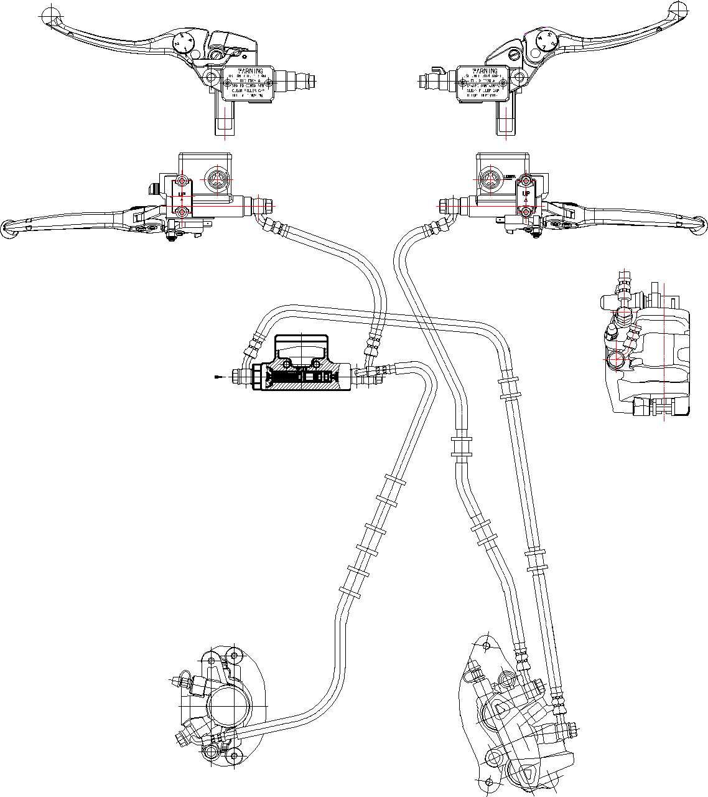

### 14.1-Precautions in operation：

 **Caution**

* Inhaling asbestos may cause disorders of respiration system or cancer, therefore, never use air hose or dry brush to clean brake parts. Use vacuum cleaner or other authorized tool instead.
* The brake caliper can be removed without removing the hydraulic system；
* After the hydraulic system is removed, or the brake system is felt to be too soft, bleed the hydraulic system；
* While refilling brake fluid, care should be taken not to let the foreign material entering into the brake system；
* Do not spill brake fluid on the painted surfaces, plastic or rubber parts to avoid damage；
* Check the operation of the brake system before riding。

**Specifications** unit: mm

|  |  |  |
| --- | --- | --- |
| Item | Standard | Limit |
| The thickness of front brake disk | 4.000 | 2.500 |
| The thickness of rear brake disk | 4.000 | 2.500 |
| Front and rear brake disk eccentricity | < 0.100 | 0.300 |
| Front brake master cylinder inner diameter | 12.7+0.055 0 | 12.765 |
| Front brake master cylinder piston outer diameter | 12.7+0.055 0 | 12.765 |
| Rear brake master cylinder inner diameter | 12.70 -0.045 | 12.645 |
| Rear brake master cylinder piston outer diameter | 12.70 -0.045 | 12.645 |
| Diameter of front disk | 240.000 |  |
| Diameter of rear disk | 220.000 | ─ |
| Thickness of front brake lining | 5.000 | 2.000 |
| Thickness of rear brake lining | 6.000 | 2.000 |

##### Torque values:

Brake hose bolts： 3.0~4.0kgf.m

Bolt for front brake caliper： 2.9~3.5kgf.m

Brake lever nut： 0.8~1.0kgf.m

Air-bleed valve： 0.8~1.0kgf.m

### 14.2-Troubleshooting:

##### Soft brake lever

1. Air inside the hydraulic system
2. Hydraulic system leaking
3. Worn master piston
4. Worn brake pad
5. Poor brake caliper
6. Worn brake lining/disk
7. Low brake fluid
8. Blocked brake hose
9. Warp/bent brake disk
10. Bent brake lever

##### Hard operation of brake lever

1. Blocked brake system
2. Poor brake caliper
3. Blocked brake pipe
4. Seized/worn master cylinder piston
5. Bent brake lever

##### Uneven brake

1. Dirty brake lining/disk
2. Poor wheel alignment
3. Clogged brake hose
4. Deformed or warped brake disk
5. Restricted brake hose and fittings

##### Tight brake

1. Dirty brake lining/disk
2. Poor wheel alignment
3. Deformed or warped brake disk

##### Brake noise

1. Dirty lining
2. Deformed brake disk
3. Poor brake caliper installation
4. Imbalance brake disk or wheel

### 14.3-Disk brake system inspection：

##### Inspection

* By visual examination whether divulges or the damage, with spanner inspection brake tube seam whether becomes less crowded, and the inspection handle bar turn right or turn left, or pressure the cushion, whether besides the pipeline protection department, whether there is interferes, contacts other parts of；

**Brake linings wear limit grooves**

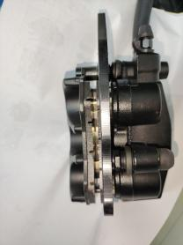

* Remove the front brake pad cap；
* Check the brake from behind the brake caliper；

**Brake caliper Brake disk**

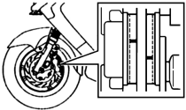

* The brake pad must be replaced with new lining when the brake pad wear limit reaches the brake disk；
* Park the motorcycle on a level ground, and check if fluid level is under the “LOWER” mark；
* Recommended Brake Fluid: WELL RUN BRAKE OIL (DOT 3).

**Liquid level observation hole**

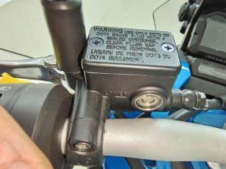

**Caution**

* The vehicles inclined or just stop, the survey oil level could not be accurate, had to settle the 3~5 minute；
* In order to prevent has the chemical change, please do not use counterfeiting or other unclear trade marks brake fluid；
* Uses by all means must with the trade mark brake fluid, guarantees the ghost vehicle efficiency。

**14.4-Add brake fluid：**

**Front brake master cylinder**

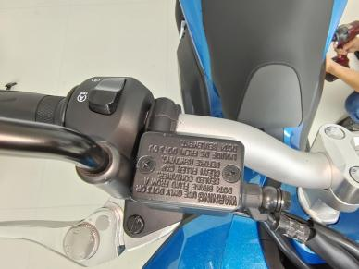

* Before the brake fluid reservoir is removed, turn the handle so that the brake fluid reservoir becomes horizontal, and then remove the brake fluid reservoir.
* When maintenance brake system, will be supposed to paint the surface or the rubber parts catches up by the rags.

 **Caution**

* Supplement brake fluid please do not surpass the upper limit, spilled brake fluid on painted surfaces, plastic or rubber components may result in their damages.
* Remove the master cylinder cap and diaphragm；

**Rear brake master cylinder**

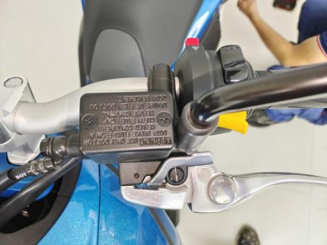

* Increases the high quality brake fluid, uses by all means must with the trade mark brake fluid joins in the master cylinder；
* Clean the dirty brake disk。

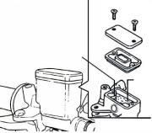

**Master cylinder cap**

**Diaphragm Upper level**

**Brake Fluid**

 **Caution**

* The dirty brake lining or disk will reduce the brake performance.
* To mixed non-compatible brake fluid will reduce brake performance.
* Foreign materials will block the system causing brake performance to be reduced or totally lost.

### G:\0-TLJ\工作文件\ADV\三业ADV-2代\三业ADV2代KS125维修手册\IMG_20230617_085247.jpgIMG_20230617_08524714.5-Brake fluid replacement / Air-bleed：

**Air-bleed valve**

1.Connect drain hose to air-bleed valve；

2.Open the drain valve on the calipers and delay valve the brake lever until the old brake fluid is entirely drained out；

3.Close the drain valve and add specified brake fluid into the brake master cylinder。

**Front brake caliper**

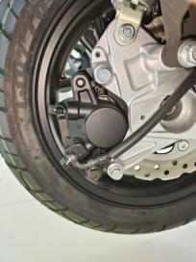Recommended brake fluid:

**Air-bleed valve**

WELLRUN DOT 3 brake fluid

4.Connect one end of transparent hose to the drain valve, and put the other end into a container；

5.Open the drain valve around 1/4 turns, and at the same time hold the brake lever until the there is no air bubble in the drain hose and also feeling resistance on the brake lever；

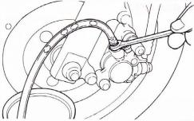

**Transparent hose**

**Air-bleed valve**

**Bubble**

**Rear brake calipersr**

6.Close the drain valve when finishing the brake system refilling fluid procedure, and operate the brake lever to check whether air bubble is in brake system or not；

7.If brake is still soft, please bleed the。

7.1.Tightly hold the brake lever and open the drain valve around 1/4 turns, and then close the valve；

7.2.Slowly release the brake lever, and wait for **Caution**

* Discharge air from the lower pump;
* The brake fluid can be replaced by machine, with shorter time and less bubbles.
* Do not release the brake lever before the drain valve is closed.
* Always check the brake fluid level when carrying out the air bleeding procedure to avoid air enter into the system.

a few seconds until it reaches its top

position；

7.3.Repeat the steps 1 and 2 until there is no air bubble at the end of the hose；

7.4.Tightly close the drain valve；

7.5.Make sure the brake fluid is in the UPPER level of the master cylinder, and refill the fluid if necessary；

7.6.Cover the cap.

### G:\0-TLJ\工作文件\ADV\三业ADV-2代\三业ADV2代KS125维修手册\IMG_20230617_085247.jpgIMG_20230617_08524714.6-Front brake caliper：

**Brake hose bolts**

##### Removal

* Place a container under the brake caliper, and loosen the brake hose bolts and finally remove the brake hoses；

C**aliper mounting bolts**

 **Caution**

* Do not spill brake fluid on painted surfaces.
* Remove two caliper mounting bolts and the caliper。

**Cotter pins**

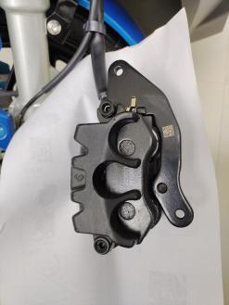

##### Installation

* Install the brake caliper and tighten the mounting bolts。

Torque: 2.9~3.5kgf.m

 **Caution**

* Use M8 x 35 mm flange bolt only.
* Long bolt will impair the operation of brake disk.

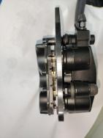

**Elastic reed**

* Use two seal washers and hose bolts to lock the hoses and brake caliper in place.

Torque: 3.0~4.0kgf.m

* Refill up the brake fluid to the reservoir and make necessary air bleeding.

##### Brake pad replacement

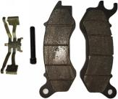

* Remove brake caliper.
* remove brake pads.
* Install the Elastic reed.
* Install the Elastic reed.new brake pads onto brake caliper.
* tighten the mounting bolts.

**Brake pad**

### G:\0-TLJ\工作文件\ADV\三业ADV-2代\三业ADV2代KS125维修手册\IMG_20230617_085809.jpgIMG_20230617_08580914.7-Rear Brake Caliper：

**Caliper mounting bolts**

##### Removal

* Place a container under the brake caliper, and loosen the brake hose bolts and finally remove the brake hoses.

 **Caution**

* Do not spill brake fluid on painted surfaces.

**Brake hose bolts**

* Remove two caliper mounting bolts and the caliper.

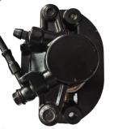

**Hexagon flange bolt**

##### Installation

* Install the brake caliper and tighten the mounting bolts.

Torque: 2.9~3.5kgf.m

 **Caution**

* Use M8 x 35 mm flange bolt only.

**Rear friction plate assembly**

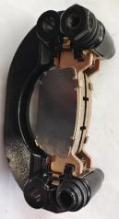

* Long bolt will impair the operation of brake disk.
* Use two seal washers and hose bolts to lock the hoses and brake caliper in place.

Torque: 3.0~4.0kgf.m

* Refill up the brake fluid to the reservoir and make necessary air bleeding.

##### Brake pad replacement

* Remove the brake caliper ；
* Remove the rear friction plate assembly flange bolt ；
* Take out the brake pads；

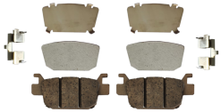

**Brake pad**

* Install the new brake pads onto brake caliper；
* Install Flange bolt and tighten。

### 14.8-Brake Disk：

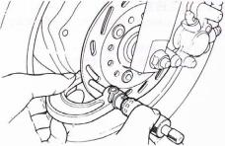

**Brake disk**

**Micrometer**

##### Inspection

* Visually check the brake disk for wear or break.
* Measure the thickness of the disk at several places.
* Replace the disk if it has exceeded the service limit.
* **Allowable limit:**

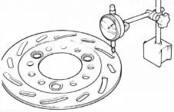

**Front brake disk 2.5mm**

**Rear brake disk 3.5 mm**

* Remove the brake disk from wheel.

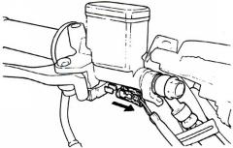

**Brake hose**

**Brake switch**

* Check the disk for deformation and bend.
* **Allowable limit: 0.30 mm**

 **Caution**

* Dirty brake linings or discs can degrade brake performance.
* Brake pads contain asbestos and cannot be cleaned with air guns. Operators should wear masks and gloves and clean with a vacuum cleaner.

### 14.9-Master Cylinder：

Master Cylinder Removal

**** **Caution**

* Do not let foreign materials enter into the cylinder.

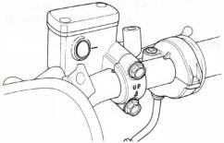

**2 bolts**

 **Caution**

* The whole set of master cylinder, piston, spring, diaphragm and cir clip should be replaced as a set.
* Remove the handlebar covers；
* Remove the leads of brake light switch；
* Drain out the brake fluid；
* Remove the brake lever from the brake master cylinder；
* Remove the brake hose；

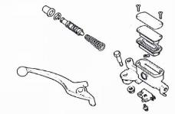

**Master cylinder**

**Spring**

**Piston**

**Piston**

**Cir clip**

**Rubber boot**

* Remove the master cylinder bolts and the master cylinder。
* Remove the rubber pad；
* Remove the cir clip；
* Remove the piston and the spring；
* Clean the master cylinder with recommended brake fluid。

##### Master Cylinder Inspection：

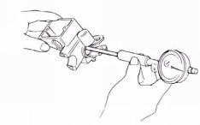

**Master cylinder**

* Check the master cylinder for damage or scratch， Replace it if necessary；
* Measure the cylinder inner diameter at several points along both X and Y directions；
* Replace the cylinder if the measured values exceed allowable limit。
* Allowable limit:

**Front brake:12.755 mm**

**Rear brake: 12.755 mm**

**Measure the outer diameter of the piston：**

* Replace the piston if its measured value exceeds allowable limit。

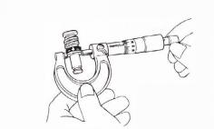

**Master cylinder piston**

* Allowable limit:

**Front brake: 12.645 mm**

**Rear brake : 12.645 mm**

**Master Cylinder Assembly**  **Caution**

* It is necessary to replace the whole set comprising piston, spring, piston cup, and cir clip.
* Make sure there is no dust on all components before assembling.
* Apply clean brake fluid to the piston cup, and then install the cup onto the piston；



**Master cylinder**

**Spring**

**Piston**

**Piston**

**Cir clip**

**Rubber boot**

* Install the larger end of the spring onto the master cylinder；
* The master cup’s cavity should be face inside of master cylinder when installing the master cup；
* Install the cir clip。

 **Caution**

* Never install cup lip in the opposite direction.
* Make sure the cir clip is seated securely in the groove.

##### Master Cylinder Install：



**2 bolts**

* Install the rubber pad into the groove correctly；
* Place the master cylinder onto handlebar, and install the bolts；
* Install the brake lever, and connect leads to brake light switch。
* Connect brake hoses with 2 new washers；
* Tighten the brake hose bolt to the specified torque value；



**Washers**

**Brake light switch**

**Brake hose**

* Make sure the hose is installed correctly；
* Install all wires, hoses, and components carefully so avoid to twisting them together.

 **Caution**

* Kink of brake leads, hose or pipe may reduce brake performance.
* Improper routing may damage leads, hoses or pipes.

**Add specified brake fluid and bleed the system**

## III. Engine maintenance

### 

### **15-Maintenance information:**

###### **Overview**

* Before all operations, please place the motorcycle on a level surface.。
* Tools
* 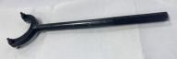Main driving wheel tightening aids Driving wheel tightening aids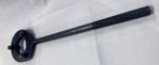

Magneto Rotor Holder:

Water pipe clamps:

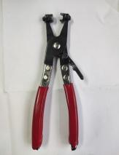

**Pipe clamps:**

### 16-Maintenance standard:

Please check according to the maintenance cycle in the maintenance table in the "Instruction Manual".

* I ：Inspect, clean, adjust, lubricate or replace if necessary;
* C：Clean；
* R：Replace；
* L：Lubrication。II. The following maintenance items require certain mechanical knowledge.Certain projects (especially those marked with \* and \*\* symbols) may require more technical information and tools.

###### Maintenance cycle table

|  |  |  |  |  |  |  |  |
| --- | --- | --- | --- | --- | --- | --- | --- |
| No. | PeriodItem | ×1000km | 1 | 6 | 12 | 18 | 24 |
| Month | 1 | 6 | 12 | 18 | 24 |
| 1 | Bolts and nuts |  | I |  | I |  | I |
| 2 | Spark plug |  |  | I | I | I | R |
| 3 | Compression pressure |  | I |  | I |  | I |
| 4 | Valve clearance |  |  |  |  |  | I |
| 5 | Oil filter |  | I | I | I | I | I |
| 6 | Engine oil |  | R | R | R | R | R |
| 7 | Coolant |  | I | I | I | I | R |
| 8 | Cooling system |  |  | I | I | I | I |
| 9 | Fuel injector |  |  |  | I |  | I |
| 10 | Cylinder head breather |  |  | C | C | C | C |
| 11 | Clutch |  |  | I | I | I | I |
| 12 | Belt |  |  | I | R | I | R |
| 13 | Rear shock absorber |  |  | I | R | I | R |
| 14 | Left crankcase cover bushing |  |  |  | L |  | L |
| 15 | Rear brake shoe |  |  | I | I | I | I |

Notice:

1. If the motorcycle is used in a harsher environment such as abnormal humidity and dust, it should be maintained more frequently.

2. \*Marking items requires special tools, data and professional skills, and needs to be carried out by Tianying dealers.

### 16.1-Crankcase breather:

**Notice:**

* In the rain or when driving at full speed, and after the motorcycle is washed or turned upside down, the maintenance frequency should be increased. Check to see if deposits are clearly visible in the clear section inside the vent drain.

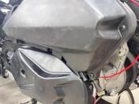

[1]

* Remove the plug [1] of the air filter cleaning pipe, and guide the sediment into a suitable container.
* Reposition the tube plug.

1. Remove the fuel tank and hold it;
2. Check the crankcase exhaust pipe [1] for cracks, aging, damage and looseness;
3. If necessary, replace the exhaust pipe;

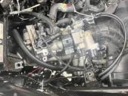

[1]

1. Install the fuel tank;

#### **16.2-Spark plug:**

#### **Remove the spark plug [1]:**

#### **Notice:**

1. Before removing the spark plug, use an air gun to blow around the base of the spark plug, and at the same time make sure that no dust falls into the combustion chamber;
2. Check whether the insulator is cracked or damaged, and whether the electrode is damaged, dirty, or discolored. Replace spark plugs if necessary.

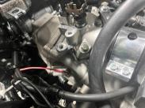

[1]

### **Check spark plugs:**1. Clean the spark plug electrode with iron wire or special spark plug cleaner;2. Check the gap between the center electrode and the side electrode with a plug gauge;Spark plug gap: (0.80～1.0)mm3. If necessary, carefully bend the side electrodes to adjust the gap;4. Install and hand tighten the spark plug to the cylinder head, then tighten the spark plug to the specified torque value.Torque value: 13N m

### 16.3-Check and adjust valve clearance:

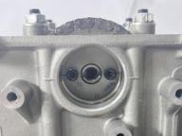

[1]

[2]

### **Check**

### Note: please check and adjust the valve clearance in a cold state (below 35°C).Remove the following parts:

* + Cylinder head cover
  + Breathing slot cover
* Turn the crankshaft counterclockwise, align the “-” mark [1] on the timing driven wheel with the joint surface of the cylinder head, and the indicating dot[2] on the timing driven wheel is perpendicular to the joint surface of the cylinder head facing the cylinder head side.

**Adjust**

**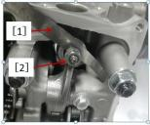**NOTE: Valve lash adjustment is accomplished by adjusting the valve adjustment screw.Insert a feeler gauge [1] between the rocker arm adjusting screw [2] and the valve to check the valve clearance.

**Valve clearance：**

**I N：(0.07±0.01)mm**

**EX：(0.15±0.01)mm**

##### 

### 16.4-Engine oil:

### **Engine oil level check**

### Start the engine and idle for (3 to 5) minutes.

### Turn off the engine and wait (2 to 3) minutes.

### Keep the motorcycle in an upright position on a level surface.

### Check the oil level on the dipstick.

### If the oil level is lower than the lower scale line, use the specified oil to add to the engine, and use the oil dipstick to confirm that the oil level is in the middle of the upper scale.

### **Specified engine oil: SF15W-40/SG15W-40**

### ●API quality level: SG or higher(Do not use oils that are marked as energy efficient on the circular API service label)

### ●JASO T903 standard: MA

### ●Viscosity: SAE15W-40

### ●Check whether the O-ring of the oil dipstick is in good condition, and replace it if necessary;

### ●Apply oil to the surface of the O-ring.

### **Install the engine oil dipstick.**

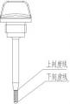

Lower tick marks

Upper tick marks

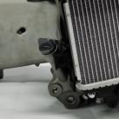

**[1]**

**Engine oil change**

1. Heating engine;
2. Turn off the engine and remove the oil drain bolt;
3. Remove the oil drain bolt [3] and washer [2] to drain the oil. After the oil is completely drained, install the oil drain bolt and replace with a new gasket;
4. Tighten the oil drain bolt to the specified torque;

5. Torque: (25～30) N•m.6. Fill the crankcase with the specified oil.

**Engine oil Capacity: New Machine: Fill 0.9L;**

[3]

[2]

**After engine maintenance or overhaul: add 0.8L to check the oil level.Make sure there are no oil leaks**

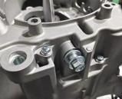

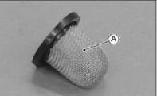Clean the oil filter

* Drain the engine oil.
* Remove the oil filter cover A and the compression spring.
* Use a solvent with a high flash point to clean the oil filter to remove the particles that stick to the oil filter.

**Warning**

1.Do not use gasoline or low flash point solvents to clean oil filters, gasoline and low flash point solvents can be flammable and/or explosive and can cause severe burns.

2. Clean the oil filter in a well-ventilated place, and

be careful not to have sparks or flames near the work area, including any lighted appliances.

* 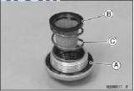Carefully check whether the oil filter A is damaged and the filter pad has fallen off.

**★**If the oil filter is damaged, please replace it.

* Replace the O-ring A with a new one.
* Install oil filter B and compression spring C.
* The side with the smaller diameter of the spring is facing down.

###### Tightening torque of oil filter cover:（20～25）N·m。

**16.5-Transmission case oil**

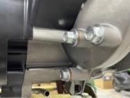

[3]

[2]

**Transmission case oil change**

1. Hot engine.
2. Shut off the engine and remove the oil drain screw.
3. Remove the oil drain bolt [2] and washer [3] to drain the oil.
4. After the oil is completely drained, install the oil drain bolt

and replace with a new gasket.

1. Tighten the oil drain bolt to the specified torque.

**Torque:(18～22) N•m.**

1. Fill the transmission case with the specified oil.

**Oil capacity:**

**New machine: refill 0.2L;**

**After engine maintenance or overhaul: add 0.12L;**

### Check the oil level to make sure there is no oil leakage.

# **Engine idle speed**

# **Notice:**

# ●After completing all maintenance items of the engine and confirming that it is within the specified range, check and adjust the idle speed.

# ●Before checking the idle speed, check the following items:

# No fault indicator flashing.

# Spark plug status

# Air filter element status

# Free travel of throttle switch and throttle handle

# ●The idle speed must be accurately checked and adjusted when the engine is warm.

# ●Start the engine, heat it up to normal operating temperature, and let it idle.

# **Check idle speed:**

# **Idle speed: (1700±150)rpm**

# If the idle speed is not within the service limits, check the following components:

# - Air intake or engine tip problems

# - Idle speed control valve operation

# 17-Cooling system maintenance:

### 17.1-Maintenance information:

**Overview**

Do not remove the radiator cap before the engine and radiator are cooled, to prevent the coolant from splashing and scalding people.

**A Warning**

##### Using coolants with added silicate corrosion inhibitors can cause premature wear of the water pump seals or blockage of the radiator passages. Using tap water can cause engine damage.

**Notice**

●Add coolant to the auxiliary water tank. Do not remove the radiator cap except to add or drain coolant.

●There is no need to remove the engine from the frame when servicing the cooling system.

●Avoid coolant leakage to painted surfaces.

●Check for leaks with a cooling system tester after system maintenance.

●Coolant temperature indicator/water temperature sensor verification.

**Cooling System Specifications**

|  |  |  |
| --- | --- | --- |
| **Item** | | **Technical parameters** |
| Coolant filling amount | | 450~470ml |
| Pump flow | Thermostat on | 15.3L/min |
| Thermostat off | 1.1L/min |
| Thermostat | Start to turn on the temperature | (80～84)℃ |
| Full open temperature | (90～94)℃ |
| Coolant recommended | | Alcohol-free, silicate-free coolant |

### 17.2-Troubleshooting:

### Engine temperature is too high

* Coolant temperature indicator/water temperature sensor failure
* The thermostat valve is not open
* Faulty radiator cover
* Insufficient coolant
* The radiator channel, hose and water pipe are blocked
* Circulation system intake
* Cooling fan failure
* Water pump failure

**Engine temperature too low**

* Coolant temperature indicator/water temperature sensor failure
* The thermostat valve is open

**Coolant leak**

* Defects in the mechanical mechanism of the pump
* O-type sealing ring aging
* Faulty radiator cover
* The cylinder head gasket is damaged or aged
* The hose connection is loose or the clamp is not clamped
* The hose is damaged or aged
* The radiator is damaged
* Thermostat cover, water pump cover pipe joints are loose.

### 17.3-Cooling system flow pattern diagram:

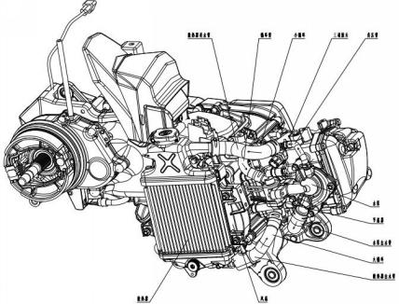

Special tooling for this chapter:



**Pipe clamp**

### 17.4-Cooling system - change the coolant:

**Notice:**

When adding coolant to the cooling system or auxiliary water tank or checking the amount of coolant, the engine should be placed on a level ground and in an upright position.

* Drain the coolant

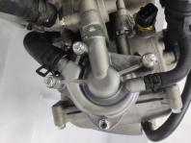

**[**1**]**

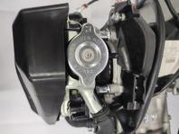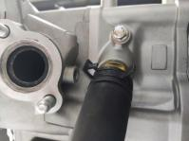

**[**2**]**

**[**3**]**

**[**4**]**

1. Remove the water pump drain bolt [1], the radiator cover [2], and drain the coolant;

2. Remove the drain bolt [3] and flat washer [4] on the cylinder block to drain the coolant.

3. After replacing the new flat washer, pre-install the drain bolts (2-3) teeth on the cylinder block, and tighten the bolts.

**Torque:**

**Water pump drain bolt: (8～12)N m**

**Cylinder head drain bolt: (8～12) N•m**

**17.5-Clean the radiator storage box:**

1. Use a pipe clamp to loosen the pipe clamp [1];
2. Remove the radiator outlet pipe [2];
3. Place the water pipe at a lower position outside the engine frame to empty the coolant in the storage tank;

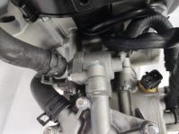

**[**2**]**

**[**1**]**

1. After emptying the coolant, rinse the inside of the storage tank with water;
2. Install the radiator outlet pipe [2] to the thermostat and install the pipe clamp [1].

* Fill coolant

Fill the cooling system with the recommended coolant up to the neck opening [1] through the radiator water injection hole.

**Recommended antifreeze: ethanol-free silicate coolant**

### **Remove air from the cooling system as follows:**

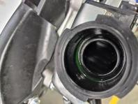

**[**1**]**

### Start the engine and let it idle for 2-3 minutes;

### Open and close the accelerator three to four times to exhaust the air in the system;

### Turn off the engine, and if necessary, add coolant.

### Install the radiator cover;

### Fill the storage tank with the recommended coolant.

### 17.6-Thermostat parts:

**NOTE:**

**If the thermostat does not open during engine start, it will need to be replaced.Removal/installation**

* Removal

1. Drain the coolant;

**[**4**]**

**[**2**]**

**[**3**]**

**[**1**]**

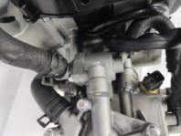

1. Use a pipe clamp to loosen the two pipe clamps [1];
2. Remove the exhaust pipe [2];
3. Remove the radiator outlet pipe [3];
4. Unscrew the thermostat mounting bolt [4];
5. Remove the thermostat.

* Installation

1. Replace with a new sealing ring [5];

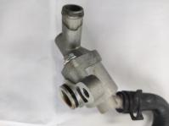

**[**5**]**

1. Tighten the thermostat mounting bolts [4];
2. Put on the exhaust pipe [2] and the radiator outlet pipe [3];
3. Use a pipe clamp to clamp the pipe clamp [1];
4. Add coolant.

### 

### 17.7-Water pump parts:

**Face Seal Inspection**

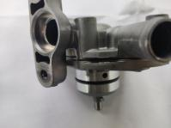

**[**1**]**

* Check the water pump overflow hole [1] to confirm whether there is coolant leakage:

1. It is normal for a small amount of coolant to flow out.
2. Make sure there is no continuous coolant leak when starting the engine.

* If necessary, replace the "water pump assembly".

### **Removal/installation**

* Removal

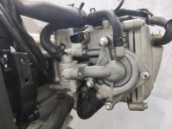

**[**2**]**

**[**1**]**

**[**3**]**

1. Drain the coolant;
2. Completely loosen the pipe clamp [1];
3. Remove the water pump outlet pipe [2] and the negative pressure pipe [3];
4. Remove the water pump.

* Installation

The installation sequence is the reverse of the removal sequence.

### 17.8-Tee joint:

**Removal/installation**

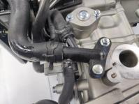

**[**3**]**

**[**4**]**

**[**2**]**

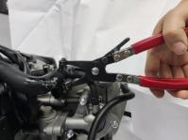

**[**1**]**

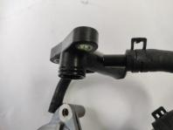

**[**1**]**

* Removal

1. Drain the coolant;
2. Use the pipe clamp [1] to loosen the three pipe clamps [2];
3. Remove the three water pipes [3];
4. Remove the bolt [4] and remove the fitting.

* Installation

1. Replace the new sealing ring [1];
2. Put on the water pipe and clamp the pipe clamp;
3. Install the bolts and tighten.

**Torque: Tightening torque (8～12)N•m**

**Notice:**

1. Replace the sealing ring;
2. The system fills or drains coolant

### 17.9-Water temperature sensor:

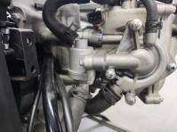

**[**1**]**

**Removal/installation**

* Removal

1. Drain the coolant.
2. Disconnect the sensor lead connector.
3. Remove the water temperature sensor [1].

* Installation

1.Apply silicone sealant to the threads [2] of the sensor [1] and tighten.

2.Fully tighten the water temperature sensor.

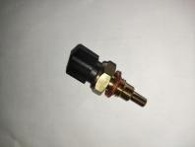

**[**1**]**

**[**2**]**

3.Add coolant.

**Torque: Tightening torque (14～16) N•m**

* Check the water temperature sensor

1. See Checking the Water Temperature Sensor in the Electrical System chapter.

### 17.10-Radiator/Cooling Fan:

# 

**Removal**

* Remove the radiator protective cover

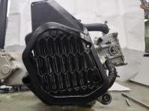

**[**1**]**

**[**2**]**

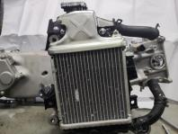

**[**2**]**

**[**3**]**

**[**1**]**

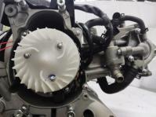

**[**2**]**

**[**1**]**

1. Drain the coolant;
2. Remove the 3 mounting bolts [1], and remove the radiator guard [2].

* Removing the radiator parts

1.Loosen the pipe clamp [1] and remove the radiator inlet pipe and radiator outlet pipe;

2.Remove the 4 bolts of the radiator water tank parts [2], and remove the radiator[3] and the lower bracket of the radiator.

# **Notice**: Do not damage the heatsink fins.

* Removing the fan

1. Remove the three fan mounting bolts [1],
2. Remove the fan [2].

**Install**

1. The installation sequence is opposite to the removal sequence.

# 18-Lubrication system maintenance:

### 

### 18.1-Maintenance Information:

**Overview**

**△！**

Repeated, prolonged skin contact with used engine oil may cause skin cancer. This is rare unless you are exposed to used engine oil on a daily basis. However, we still recommend that you wash your hands with soap and water as soon as possible after handling used oil.

**A Warning**

* When repairing the oil pump, it is necessary to remove the engine (see Chapter 8 Maintenance Guide for the Case).
* The premise of each maintenance procedure in this chapter is to drain the engine oil.
* When removing and installing the oil pump, be careful not to allow dust and dirt to enter the engine.
* If any parts of the oil pump are worn beyond the specified maintenance limit, please replace the components, and the inner and outer rotors of the oil pump should be replaced together.
* After installing the oil pump, check for oil leakage. .

**Lubrication System Specifications**

|  |  |  |  |  |
| --- | --- | --- | --- | --- |
| **Item** | | | **Standard value** | **Maintenance threshold value** |
| Engine oil filling amount | New engine | Crankcase | 900ml | - |
| Transmission case | 80W-90 Gear oil filling 200mL | - |
| After parsing | Crankcase | 800ml | - |
| Transmission case | 80W-90 Gear oil filling 120mL | - |
| Lubricant grade | | | SF15W-40/SG15W-40 | - |

### 18.2-Troubleshooting:

### **Oil level too low**

* High oil consumption
* Oil leakage from external parts
* Piston ring is worn or not installed properly
* Cylinder block wear
* Valve guide wear➢

**Oil pressure too low**

* Oil level is too low
* The oil filter is clogged
* Oil leakage from internal components
* Improper use of oil

### **No oil pressure**

* Oil level is too low
* Oil pressure relief valve is open and stuck
* The main and driven gear teeth of the oil pump are broken
* Oil pump damage
* Oil leakage from internal components➢

**Oil pressure too high**

* Oil pressure relief valve closed
* The oil filter, oil return hole and oil measuring hole are blocked
* Improper use of oil➢

**Dirty oil**

* No regular oil and filter changes
* Piston ring damage➢

**Oil emulsification**

* Cylinder head cover expansion and cracking
* Coolant channel leakage
* The engine is flooded with water➢ ➢

### 18.3-Flow diagram of lubrication system

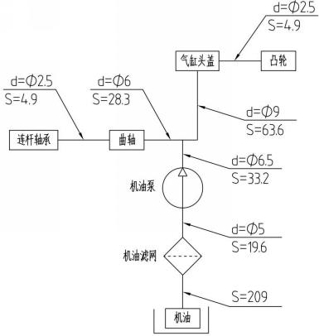

Engine oil

Oil filter

Oil pump

Crankshaft

Connecting rod bearing

Cam

Cylinder head cover

### 

### 

### 18.4-Engine oil pump:

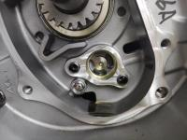

**[**1**]**

**[**2**]**

**[**1**]**

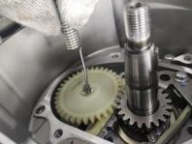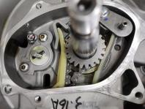

**[**4**]**

**[**3**]**

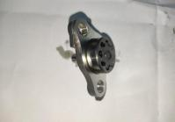

**[**3**]**

**[**2**]**

**[**4**]**

**[**1**]**

### **Removal**

### Remove the magneto and the right crankcase cover (see other chapters in the maintenance guide for details);

### Use a suitable tool to remove the oil pump opening retaining ring [1];

### Remove the oil pump driven wheel [2];

### Remove the two socket head cap screws [3] and take out the oil pump [4].

### **NOTE: Drain the oil before disassembly.**

* Decomposition oil pump

1. Inner rotor [1];
2. Outer rotor [2];
3. Oil pump cover [3];
4. Oil pump shaft [4].

**Install**

1. The installation process is opposite of removal process.

**Notice:**

1. Apply lubricating oil when assembling the inner and outer rotors of the oil pump.
2. Check that the positioning pins are installed in place.
3. Check whether the oil pump drive shaft rotates freely.
4. Replace with a new oil pump opening retaining ring.

**Oil pump bolt tightening torque: (8～12)N·m.**

**Check**

* Inspection of the main and driven wheels of the oil pump:Check the following parts for damage, abnormal wear, deformation, burning.

1. Oil pump shaft
2. Inner rotor
3. Outer rotor

4. Oil pump rotor hole

* Determine the oil pump clearance according to the measured value of the lubrication system; if any measured value exceeds the specified maintenance limit value, please replace the worn parts, and replace the inner and outer rotors of the oil pump together as a set.

**18.5-Engine oil filter:**

**Removal:**

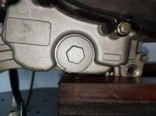

**[**1**]**

1. Drain the oil;
2. Remove the valve cover [1];
3. Remove the sealing ring [2], the compression spring [3] and the oil filter [4].

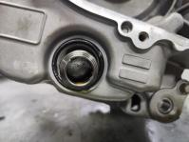

**[**4**]**

**[**3**]**

**[**2**]**

**Install:**

The installation process is the opposite of the removal process.

**Notice:**

1. Replace the sealing ring with a new one.

2. Screw the valve cover into the hole of the left crankcase body, and tighten the torque.

**Valve cover tightening torque: (20～25)N·m.**

**Check:**

1. Check whether the oil coarse filter is damaged, if damaged, replace it directly.

2. Clean the coarse oil filter with a high flash point solvent to remove particles stuck to the oil filter.

# 

# 19-Cylinder head and valve:

19.1-Maintenance Information:

### **Overview**

* This chapter covers the maintenance and inspection of the cylinder head, valve, camshaft and rocker arm.
* When repairing the camshaft, rocker arm, and tensioner adjusting screw, it is not necessary to remove the engine from the frame; when repairing the cylinder head and valve, the engine must be removed from the frame.
* When disassembling, mark and place the disassembled parts to ensure proper homing during reassembly.
* Before inspection, all disassembled parts should be cleaned with detergent and dried with compressed air.
* The camshaft lubricating oil is injected through the oil pipeline in the cylinder head and the cylinder head cover, so the oil pipeline should be cleaned before assembling the cylinder head and the cylinder head cover.
* When removing the cylinder head and cylinder head cover, be careful not to damage the joint surface.

##### C:\Users\Administrator\Desktop\未标题-1.jpg未标题-1Tools

valve guide reamer

knife holder

valve seat adjust cutter,27.5mm(IN,45º)

valve guide adjustment drive

Valve catheter drive

Valve spring compression accessories

Valve spring compression tool

Tensioner clip

Pressure Gauge Accessories

### 

Flat milling cutter,24mm(EX,32º)

Flat milling cutter,28mm(IN,32º)

valve seat adjust cutter, 24mm(EX,45º)

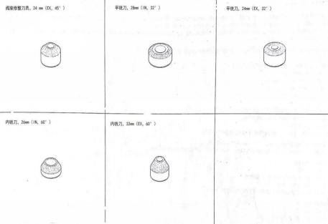

Internal milling cutter, 26mm (IN, 60º)

Internal milling cutter, 32mm (EX, 60º)

### Cylinder Head/Valve Specifications unit: mm

|  |  |  |  |
| --- | --- | --- | --- |
| Item | | Standard | Limit of use |
| Valve rocker arm | Clearance between valve rocker arm and valve rocker arm shaft mm | 0.026～0.059 | 0.079 |
| Camshaft Cam Height | Exhaust mm | 33.676～33.776 | 33.666 |
| Intake mm | 33.463～33.563 | 33.453 |
| Cylinder head | Cylinder pressure kpa | Available range:800～1200(900～1100rpm) | / |
| Flatness mm | 0.05 | 0.05 |
| Valve clearance | Intake valve mm | 0.06～0.08 | / |
| Exhaust valve mm | 0.14～0.16 | / |
| Clearance between valve and valve catheter | Intake valve mm | 0.01～0.037 | 0.057 |
| Exhaust valve mm | 0.03～0.057 | 0.077 |
| Valve spring free length | Outer valve spring mm | 36.5 | 35.9 |

### 

### 19.2-Troubleshooting:

* A top-end failure of an engine usually affects engine performance. These faults can be diagnosed with a compression test, or the source of engine noise can be traced down to the tip using a probe rod or stethoscope.
* If the engine does not perform well at low speed, check the crankcase breather for white smoke. If the hose is smoking, check for a stuck piston ring.

**Compression pressure is too low, difficult to start, or poor performance when the engine is running at low speed:**

* Valve

1. Improper adjustment of valve clearance
2. Burned or bent valve
3. Improper valve timing

4. Broken valve spring

* Cylinder head

1. The cylinder head gasket is leaking or damaged
2. Warped or cracked cylinder head
3. The spark plug is loose

4. Cylinder, piston, piston ring wear

**Excessive compression pressure, overheating, or knocking noise:**

* Excessive carbon deposits in the piston head or combustion chamber
* The EFI system is abnormal

**Too much noise:**

* Cylinder head

1. Improper adjustment of valve clearance
2. The valve is stuck or the valve spring is broken
3. Camshaft is worn or damaged
4. Worn rocker arm or rocker arm shaft
5. Rocker arm and valve rod end wear
6. Loose or worn cam chain
7. Timing chain wear
8. Cam sprocket wear
9. The pressure reducing valve on the camshaft is stuck

* Cylinder, piston, piston ring wear

###### **Excessive smoke:**

* Cylinder head

1. Worn valve stem or valve guide

2. Damaged valve stem seals

* Cylinder, piston, piston ring wear

###### **Bad idle speed:**

* Cylinder compression pressure is too low

******19.3-Cylinder head component location:**

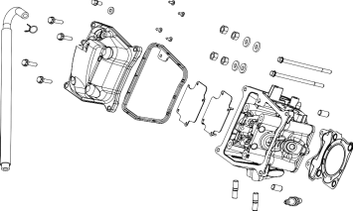

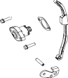



****

### 19.4-Cylinder compression test:

### Heat the engine to normal working temperature;

### Stop the engine and remove the spark plug;

### Temporarily install the ECM harness to connect the 33 (black) connector;

### Install the threaded end of the cylinder pressure gauge [1] into the spark plug hole.

### **Tool:**

### **Pressure gauge**

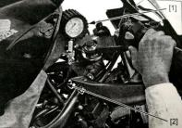

### **[2] Compression Gauge Accessories**

1. Turn the ignition switch to "ON" and the engine switch to " ".

6. Keep the maximum throttle open and start the engine until the pressure gauge reading no longer rises.

7. The maximum reading will usually last 4 to 7 seconds.

**Compression pressure: (800～1200)kPa at (900～1100)rpm**

Analysis of the cause of low pressure:

1. Cylinder head gasket leakage
2. Improper adjustment of valve clearance
3. Valve leakage
4. Piston ring or cylinder wear

High pressure cause analysis:

1. Product build up in the combustion chamber or on the top of the piston

**19.5-Cylinder head cover:**

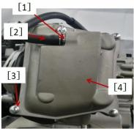**Removal**

1. Remove the pipe clamp [1] and the breather pipe [2].

2. Remove the 4 cylinder head cover mounting bolts [3] and the cylinder head cover [4].

**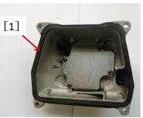**

**Install the cylinder head cover**

3.Replace a new cylinder head cover gasket [1];

4. Install the cylinder head cover and fasten it;

**Bolt torque: 8～12N m**

1. Install ventilation pipes and pipe clamps;

6. Install the removed parts.

### 19.6-Chain tensioner:

This is not a self-returning tensioner. When the push rod is pushed out to compensate for the slack in the timing chain, the push rod will not return to its original position.

The following principles must be followed:

When removing the tensioner, do not remove only one side of the mounting bolts, as this will easily damage the tensioner and timing chain. Once the bolts are loosened, the tensioner must be removed and reset as described in Installing the Tensioner. Do not turn the crankshaft when removing the tensioner, it may disrupted timing and damaged valves.

**Notice**

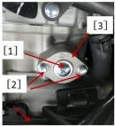

Removal:

1. Tensioner bolt

2. Tensioner mounting bolts

3. Tensioner body

* Installation:

1.Using a suitable screwdriver, turn clockwise until the

push rod (1) retracts into place.

**Notice**

Do not turn the pusher counterclockwise until the tensioner is installed

lever, may disengage the push rod and prevent the tensioner from being reinstalled.

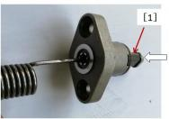

1. 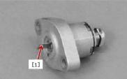Replace the tensioner gasket with a new one.
2. Hold the push rod in place with a suitable push rod support plate [1], then install the tensioner on the cylinder block.
3. Tighten the tensioner mounting bolts [1];

**Torque: (8~12)N m**

1. Remove the support plate [2];
2. Replace with a new sealing ring;
3. Apply an appropriate amount of oil on the new sealing ring;

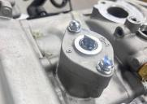

[2]

[1]

1. Install a new sealing ring and tighten the tensioner bolts;
2. Install the other parts removed.

### 19.7-Rocker arms and rocker shafts:

Do not install the rocker arms of the intake and exhaust valves wrongly, as shown in the figure on the right,

[1] is the exhaust valve rocker arm marked as "E", [2] is the intake valve rocker arm, marked as "I"

**Notice**

**Remove valve rocker arm**

* Removal:

1. Timing sprocket installation screw[1];

2. Timing driven wheel [2];

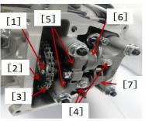3. Use a suitable tool to support the timing chain [3];

4. Remove the rocker shaft mounting bolts [4];

5. Remove the valve rocker shaft [5] with a suitable tool;

6. Intake valve rocker arm [6] and exhaust valve rocker arm [7];

7. Mark and record the position of the valve rocker arm so that it can be installed back to its original position;

8. The valve rocker arm and the valve rocker arm shaft fall off together.

##### Install the valve rocker arm

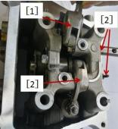

［3］

1. Apply oil on the following parts:

① Valve rocker shaft

② Cylinder head rocker shaft mounting hole

2. Install the following parts as shown:

① Intake valve rocker arm [1]

② Exhaust valve rocker arm [2]

③ Valve rocker shaft [3]

##### Check the valve rocker arm and valve rocker shaft

1. Check the outer circle [1] of the roller bearing on the valve rocker arm.

★If the rocker arm bearing is scratched, collapsed or otherwise damaged, please replace the valve rocker arm and check the camshaft tip.

2. Check where the valve adjusting bolt [2] contacts the valve.

★If the end of the valve adjusting bolt is mushroom-shaped or otherwise damaged, or the bolt does not turn smoothly, please replace it and check the end of the valve at the same time.

3. Insert the rocker arm shaft into the rocker arm and measure the clearance.

★If the gap exceeds the limit of use, please replace it at the same time.

**Valve rocker arm/valve rocker arm shaft clearance**

**Standard: (0.026～0.059)mm; Use limit: 0.079mm.**

### 19.8-Camshaft:

**Removal:**

1. Cooling pump;
2. The timing sprocket rotates in place (top dead center of the piston);
3. Use suitable tools to support the timing chain;
4. 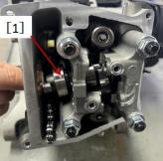Remove the valve rocker arm shaft and intake and exhaust valve rocker arms;
5. Remove the camshaft pressure plate bolt [1];
6. Remove the camshaft [2].

**Install**

1.Before assembling the camshaft, oil should be applied to all the joint surfaces of the cam parts [1];

2.Install the camshaft pressure plate;

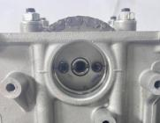

[2]

[3]

[1]

**Bolt torque: (8～12)N m**

3.Combine the timing chain with the timing driven wheel;

4. Assemble the driven wheel mounting bolts.

5. Bolt torque: (5～9)N m

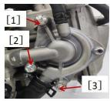▅ Keep the dot mark [1] of the timing follower facing upward, and the line formed by the marking “-” mark [2] is parallel to the upper plane [3] of the cylinder head (the lobes of the intake and exhaust cams face downward).

6.Install the cooling pump and thermostat components

7. Tighten the bolts [1][2][3]

**Bolt torque: (8～12)Nm**

8. Install water pipe clamps with special tooling.

9. Install the tensioner.

10. Turn the crankshaft 2 turns clockwise to open the tensioner and recheck the timing to adjust the valve clearance.

11.Install the removed parts.

**Check cam wear**

* Remove the camshaft;
* 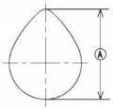Use a micrometer to measure the height A of the cam;

★If the measured value exceeds the cam wear limit, replace the camshaft.

* **Cam height standard:**

**Intake: (33.676～33.776)mm**

**Exhaust: (33.463～33.563)mm**

**Limit of use:**

**Intake: 33.666mm**

**Exhaust: 33.453mm**

**Check camshaft bearings**

* **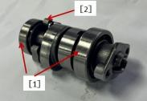**Inspect each bearing [1] that is press-fit on the camshaft. Check whether the pressure reducing valve is normal, and whether the toggle fly block [2] returns normally.
* Because the manufacturing tolerance of the bearing is very small, the wear of the bearing must be based on the feel rather than the measurement. Clean the bearing with a high flash point solvent, dry (do not rotate the bearing when dry), and lubricate with oil.
* Quickly rotate the bearing by hand to check its condition.

★If the bearing has abnormal noise, does not rotate smoothly or stops suddenly, replace the camshaft.

##### 19.9-Timing chain:

##### **Remove the timing chain**

* Cooling pump parts
* Timing sprocket
* Cylinder head
* Cylinder block
* Oil pump driven wheel [1]
* Chain guide plate [2]
* Timing chain limit plate[3]
* Chain Tension Plate[4]
* Remove the timing chain [5] from the timing sprocket.

**Install the timing chain**

* 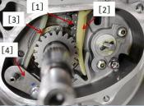Hang the timing chain [1] on the timing driving wheel;
* Installation:

1. Chain guide plate [2]

2. Chain tension plate [3]

3. Guide plate bolts [4]

4. Tension Plate Bolts

**Tightening torque: (10～15)N m**

* Install the disassembled parts.

**Check chain guide and tensioner plate for wear**

* Visually inspect the joint surface of the guide plate and the tension plate

★If the rubber is damaged, cut or peeled, replace the guide plate and tension plate.

### 19.10-Cylinder head:

**Measuring cylinder pressure**

**Notice**

Use a fully charged battery

1. Warm up the engine, then stop;
2. Remove the spark plug;
3. Connect the cylinder pressure gauge [1] and the adapter [2] firmly to the spark plug hole;

**Tools -1. Cylinder pressure gauge 20kg/cm2**

**-2. Adapter M12×1.25**

4. Start the engine and fully open the accelerator until the cylinder pressure gauge reading no longer rises. At this time, the cylinder pressure gauge reading is the highest cylinder pressure.

**Available range of cylinder pressure: (800～1200)k pa/(900～1100)rpm**

If the cylinder pressure gauge reading is not within the usable range, see the table below:

|  |  |  |
| --- | --- | --- |
| **Problem** | **Diagnosis** | **Remedy** |
| Cylinder pressure above usable range | Carbon deposits on the piston, cylinder head, combustion chamber may be due to damage to the oil shield and/or damage to the piston oil ring (white smoke) | Remove carbon deposits and replace damaged parts if necessary |
| Incorrect cylinder head gasket thickness | Replace with standard size gasket |
| Cylinder pressure below usable range | Gas leaks around the cylinder head | Replace damaged gaskets, check gun |
| Abnormal valve spring seat | head deformation |
| incorrect valve clearance | Replace if necessary |
| Incorrect piston/cylinder clearance | Adjust valve clearance |
| Piston Cylinder | Replace piston and/or cylinder |
| Abnormal piston ring and/or piston ring groove | Check cylinder, replace/repair if necessary |

##### **Remove the cylinder head**

* Drain the coolant
* 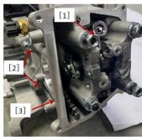Removal:

1. Intake pipe Exhaust pipe Spark plug cap
2. Cooling pump parts camshaft
3. Hexagonal nut[1]
4. Flat washer hexagon head flange bolt[2]
5. Cylinder head [3]
6. Cylinder head gasket

##### **Install the cylinder head**

* **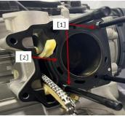**Replace the cylinder head gasket with a new one.
* Installation:

1. Locating pin[1]
2. New cylinder head gasket [2]
3. Cylinder head
4. Camshaft

* Tighten the cylinder head hexagon head bolts.

**Tightening requirements: Tighten nuts diagonally and crosswise at 15N•m and 25N•m respectively, until the tightening torque is (28～32) N•m.**

##### **Clean the cylinder head**

* Remove the cylinder head;
* Use suitable tools to scrape off the carbon deposits in the combustion chamber and exhaust port;
* Clean the cylinder head with a solvent with a high flash point.

### Check cylinder head deformation

* Clean the cylinder head;
* Put a ruler on the lower plane of the cylinder head;
* Use a feeler gauge [1] to measure the gap between the ruler [2] and the lower plane of the cylinder head at several positions.

**Cylinder head deformation- Standard: no gap;-Usage limit: 0.05mm.**

★If the deformation of the cylinder head exceeds the limit of use, please replace it.

★If the deformation of the cylinder head is lower than the usage limit, grind the lower surface with fine sandpaper.

### 19.11-Valve:

### Check valve clearance

Check the valve clearance only when the engine has cooled to room temperature.

**Notice**

* Removal: cylinder head cover;
* Radiator protection cover radiator;
* The combination of the lower bracket of the radiator;Turn the magneto housing clockwise until the "T" mark [1] on the magneto rotor aligns with the boss [2] on the right crankcase as shown: end of cylinder compression stroke.
* Use a feeler gauge [1] to measure the valve clearance, measure the clearance between the end of the valve stem and the adjusting screw [2].
* Valve clearance (cold engine)

**Exhaust valve: (0.06～0.08)mm Intake valve: (0.14～0.16)mm**

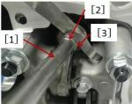★If the valve clearance is incorrect, please adjust the valve clearance.

**Adjust valve clearance**

* Loosen the lock nut and turn the adjusting screw until the clearance is correct;
* Use the clamp [1] to stabilize the adjusting screw [2], and tighten the lock nut [3];

**Tightening torque of lock nut: (7～11)N·m.Tools - Adjusting Screw Clamps.**

* Recheck valve clearance.

★If the gap is not correct, readjust it.

★ If the clearance is correct, adjust the clearance of the other valve.

**Remove the valve**

* Remove the cylinder head;
* Mark the valve position so that it can be installed back to the original position;
* Remove the valve with the valve spring compression device [1] and adapter [2].

**Tools - valve spring compression device;**

**Install the valve**

* Replace the oil shield [3].
* If a new valve is to be used, check the clearance between the valve [1] and the valve guide.
* If the clearance is too large or too small, replace the cylinder head.
* Apply oil to the valve stem and install the valve and spring lower seat [2].
* Install the valve spring [4] with the sparse coil facing up and the tight coil facing down.
* Install the valve spring upper seat [4]
* Install the lock clip [6]

**Measure valve and valve guide clearance**

* Measure the outer diameter of each valve stem and the inner diameter of each valve guide.
* Subtract the outer diameter of the valve stem from the corresponding inner diameter of the valve guide to obtain the clearance between them.

★If the clearance exceeds the usage limit, replace the cylinder head.

* **Valve and valve guide clearance**

**Standard:**

**Intake valve: (0.01～0.037)mm**

**Exhaust valve: (0.03～0.057)mm**

**Limit of use:**

**Intake valve: 0.057mm**

**Exhaust valve: 0.077mm**

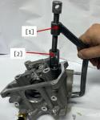





**20-CVT system:**

**20.1-Maintenance information:**

**Overview**

* This chapter explains the maintenance of clutches and shifting mechanisms. All without removing the engine from the frame.
* Oil viscosity and oil level will affect clutch disengagement. When the clutch is not disengaged or the motorcycle is still moving slowly, check the oil level before overhauling the clutch system.

##### Tools

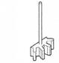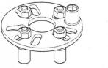

### Technical parameters

Unit: mm

|  |  |  |  |
| --- | --- | --- | --- |
| **Item** | | **Standard** | **Limit of use** |
| Belt | Belt width mm | 22.3～22.9 | 21.3 |
| Main drive pulley belt Parts | Sliding drive plate mounting hole diameter | 24～24.021mm | 24.061 |
| Sliding drive disc sleeve outer diameter mm | 23.959～23.980 | 23.559 |
| Roller outer diameter mm | 19.9～20.1 | 19.4 |
| Driven wheel belt parts | Mounting hole diameter of driven sliding plate combination mm | 34～34.039 | 34.079 |
| Driven fixed plate combination installation shaft diameter mm | 33.966～33.991 | 33.916 |
| Free length of compression spring mm | 144 | 139 |
| Thickness of friction material of clutch shoe block combination | 2.95～3.05 | ＜1 |
| Inner diameter of clutch outer disc mm | 125～125.2 | 125.5 |

******20.2-Troubleshooting:**

**Clutch slips when accelerating**

* Belt wear
* Clutch shoes are worn or ablated

**Clutch noise**

* Abnormal wear of the cambered surface of the roller
* The welding of the clutch friction disc is loose
* Clutch grease failure

### **20.3-**Component layout:







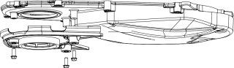





### 20.4-Left crankcase case cover

### 

### Removal

1. Removal
2. Breathing groove cover bolt
3. Left cover mounting bolt[2]
4. Left crankcase cover [3] and gasket.

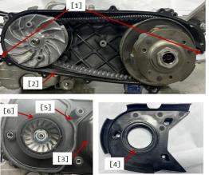

**Install**

1. Replace with a new filter screen, sealing strip and sealing ring;
2. Installation:
3. Location pin[1]
4. Gasket[2]
5. Left crankcase cover[3]
6. Sealing ring[4]
7. Sealing strip[5]
8. Filter[6]。

* Tighten the bolts of the left crankcase cover and the outer cover plate of the breathing tank.

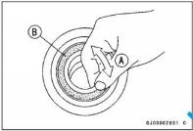**Tightening torque of left crankcase cover mounting bolts: (8～12)N m**

**Check bearings**

Do not remove the bearing for inspection. If the bearing is removed, it needs to be replaced with a new one.

**Notice**

* Turn bearing A back and forth when checking whether there is a gap and whether the rotation is flexible.

##### ★If the bearing is found to have clearance, roughness or adhesion, the bearing should be replaced.

* Check the bearing end face B for cracks.

##### ★If there are cracks on the sealing surface, left cover.

##### **CVT cavity drain**

##### **Notice:** the CVT cavity is not allowed to enter the water. If the water enters, please remove the cable clip [1] and the water pipe [2], and drain clean water. At the same time, remove the left crankcase cover, and then tighten the bolts of the left crankcase cover after drying the relevant parts.

### 20.5-Belt:

**Removal**

* Remove the drive pulley parts.
* Remove the clutch outer disc.

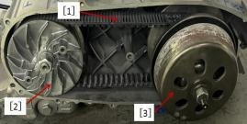

Before removal, observe the orientation of the information [1] (such as the manufacturer's name) stamped on the belt so that the belt can be re-installed on the pulley in the same direction of rotation as it was originally installed.

**Notice**

* Remove the driving pulley part [2] and the driven pulley part [3].

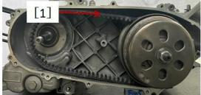**Install**

Make sure the engraved information is facing the same direction so that the belt can be installed back to its original rotation. When a new belt is installed, the imprinted information [1] can be read from the side of the vehicle.

**Notice**

* The installation and removal steps are reversed.

**Check belt wear**

* Remove the left crankcase cover.
* 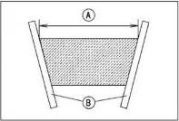Measure the width A of the belt at several locations with a suitable pair of rulers as shown.

★If the measured value exceeds the usage limit, please replace the belt.

* Belt width

**Standard: (22.3～22.9)mm**

**Use limit: 21.6mm**

* Check the belt for cracks, breaks or peeling.
* 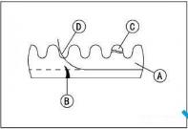The belt should be inspected and cleaned every 6000km (6 months), according to the wear condition, it needs to be replaced when it needs to be replaced, and it needs to be replaced after 12000km;
* **Code annotation**

Belt A

Crack B

fracture C

flaking D

Any mishandling or clutch stall slip can cause severe wear or damage to the belt, seizing the derailleur and wheels. This could result in loss of operator control and an accident resulting in injury or death.

Perform maintenance according to the maintenance schedule.

**Warning**

**Notice**

When replacing the belt, check the drive pulley components and

Driven pulley parts.

### 20.6-Main drive pulley parts:

**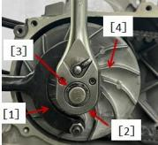**

**Removing the drive pulley assembly**

* Remove the left crankcase cover parts.
* Install the anti-rotation tool [1], and remove the drive pulley installation nut [2] and bushing [3].
* Remove the drive disk [4].

**Tools - Anti-rotation tooling.**

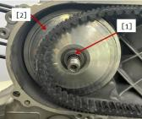

* Removal:

Sliding drive disc sleeve [1]

Slide the drive disk [2]

* 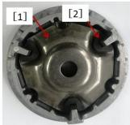Removal:

Ramp plate[1]

Ramp plate side piece[2]

●

* Removal:

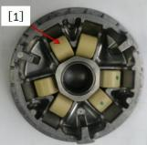Counterweight Roller[1]

**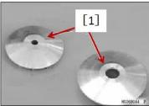Check main drive pulley parts**

★ If the drive pulley surface [1] is damaged, replace the sliding drive plate and/or drive plate.

★ If the drive plate mounting hole is damaged or worn, please replace the drive plate.

* Sliding drive plate mounting hole A

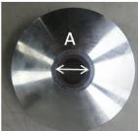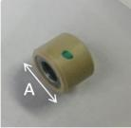**Standard: 24～24.021mm**

**Use limit: 24.06mm**

★If the bushing is damaged or worn, please replace it.

* Bushing outer diameter A

**Standard: 23.959～23.998mm**

**Use limit: 23.92mm**

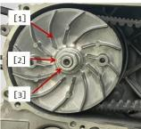★The rollers should be inspected and cleaned every 5000km (6 months), and should be replaced according to the wear and tear.

* Outer diameter of roller A

**Standard: 19.9～20.1mm**

**Use limit: 19.4mm**

**Install the drive pulley assembly**

* Installation and removal are just the opposite.

Note: Clean the following parts with degreaser, then dry the drive disc cone, crankshaft, and belt with a clean rag.

These cleaners are usually highly flammable and harmful if breathed in for extended periods of time. Be sure to heed the manufacturer's warnings.

**Warning**

**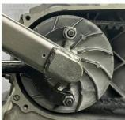**

* When installing the drive disc [1], press the sliding drive disc sleeve to make the belt move outward to the lowest position, then install the bushing [2], apply a small amount of oil to the thread of the nut [3] and then assemble.
* Install the anti-rotation tool and tighten the pulley nut.
* Tighten the drive pulley nut

Torque: (63～77) N·m.

Tools - Anti-rotation tooling.

### 20.7-Driven pulley parts:

**Removing the driven pulley assembly**

* Removal: Left crankcase cover

Drive Pulley Parts

* Install the anti-rotation tool [1], and remove the driven pulley installation nut [2].
* Remove the gasket and clutch friction disc [3].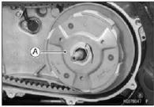
* Removal: driven pulley part [A]

##### **Removal the driven pulley assembly**

Always use a clutch spring compressor to avoid damage to the compression spring.

**Notice**

**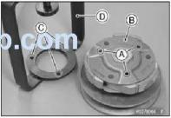**

* Fix the hole on the driven pulley assembly [A] to the pin of the clutch spring compression device [D];
* Fixed driven pulley assembly and clutch spring compression device;

**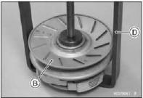Tools - Clutch Spring Compressor.**

* Clamp the clutch spring compression device [D] on the vise;
* Use a 39mm hex nut wrench to remove the clutch disc nut;
* 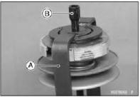Loosen the clutch spring compression device and remove the driven pulley assembly;
* Remove the clutch drive plate assembly.

**Check the driven wheel parts**

* Inspect and clean every 5000km (6 months), according 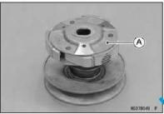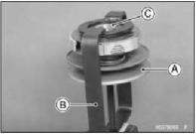to the wear and tear, replace it when it needs to be replaced, and need to replace it after 15000km;
* The maximum thickness of the clutch shoe is 1mm, and the driven pulley should be replaced.
* Check the use of bearings and oil seals, and replace if necessary.

**Assembling the driven pulley part**

1. Fit the hole of the driven pulley part [A] to the pin of the clutch spring compressor [B].

2. Fix the driven pulley assembly and clutch spring compressor.

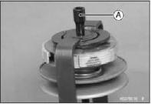3. Place the clutch spring compressor in a bench vise.

4. Temporarily tighten the clutch disc nut [C].

5. Using a 39 mm hex nut wrench, tighten the clutch disc nut to the specified torque.

6. Release the clutch spring compressor and remove the driven pulley assembly.

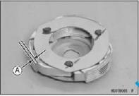Check the clutch

* Check whether the clutch shoe is damaged.
* ★If there is any damage, please replace it.
* Measure the thickness A of the clutch lining.
* ★If the thickness of the lining exceeds the limit of use, please replace the clutch shoe.
* Clutch lining thickness

**Standard: 3.6～4.4mm Use limit: 2mm**

* Check whether the clutch outer disc is damaged.

★ If there is any damage, please replace it.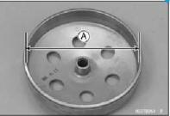

* Measure the inner diameter A of the outer disc of the clutch.

★ If the outer disc of the clutch is worn beyond the limit of use, please replace it.

* Inner diameter of clutch outer disc.

**Standard: 125～125.25mm**

**Use limit: 125.5mm**

**Install the driven pulley assembly**

* 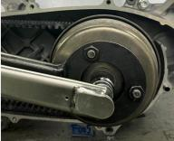Install the belt and driven pulley parts.
* Install the clutch outer disc and bushing.
* Apply oil on the top of the driven shaft.
* Install the anti-rotation tooling and tighten the mounting nut of the driven pulley.

**Tools - Anti-Rotation Tooling**

**Pulley mounting nut tightening torque: 43 to 53 N m**

**21****-Magneto system maintenance:**

### 21.1-Maintenance information:

### **Overview**

* This chapter explains the maintenance of magneto spindles and rotors. All without removing the engine from the frame.
* Checking the alternator charging coil.
* Checks about triggers.

Tools

|  |  |
| --- | --- |
| Magneto Rotor Holder | The magneto rotor exits the tooling |
|  |  |

### 

### 21.2-Troubleshooting:

**Engine does not start**

* Controller failure
* Magneto failure

### 21.3-Magneto:

**Remove the magneto**

1. Remove the radiator protective cover, radiator components and fans;

**(See Chapter 3 Cooling System for details)**

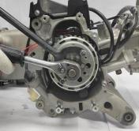

[2]

[1]

1. Use the magneto holder to fix the magneto rotor [1];
2. Use the torque wrench [2] to remove the tightening nut;
3. Remove the fastening nut and the flat washer;

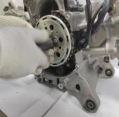

[3]

1. Use the motor rotor holder to prevent the rotor from rotating.
2. Use the magneto to eject the tooling [3] and remove

the magnetic steel;

**Notice:**

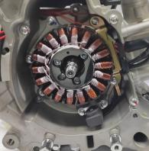

[2]

[4]

[3]

A motor rotor holder block is required to prevent the rotor from rotating.

1. Remove:

Trigger Fastening Bolt [2]

Clamping plate bolt [3];

1. Take off the pressure plate [4];
2. Use an Allen wrench to remove the fixing screws [1] of the stator, and remove the magneto stator part.

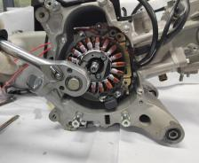

[1]

**Check the magneto**

* Check the following parts for scratches, damage, abnormal wear or deformation. Replace if necessary.

-Half circle key

-Magneto rotor

-Magneto stator

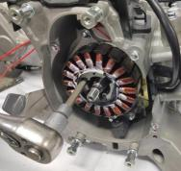

[1]

-Trigger

**Install the magneto**

* Before installing the stator components, place the trigger harness[1] in a suitable position in the box

1. Install the socket head cap screws and tighten to the specified torque.

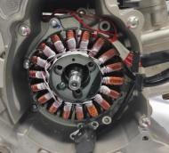

[1]

**Torque: 10N•m (10kgf•m, 7.4lbf•ft)**

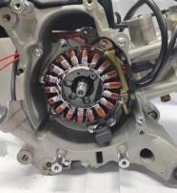2.Adjust the trigger harness, install the pressure plate, and tighten the bolts to the specified torque.

3.Install the trigger retaining bolt and tighten to the specified torque.

**Torque: 9N•m (9kgf•m, 6.66lbf•ft)**

### Install the stator, assemble the flat washer to the crankshaft, and tighten the nut to the specified torque.

### **Torque: 90N•m (90kgf•m, 66.6lbo•ft)**

### Use the rotor fixing tool to lock the crankshaft.

### Install the rotor. (The order is reverse to the disassembly order)

### **Notice:**

* Remove grease from the crankshaft cone and rotor cone.
* Apply 1262 thread glue before installing the nut, apply half a circle of thread glue, and wipe off excess glue after tightening.

### Install the fan, radiator assembly and radiator guard.

### 22-Housing and transmission maintenance:

### 22.1-Maintenance information:

**Overview**

* The engine must be detached from the frame.
* The crankcase must be separated to serve the following parts:

1. Drive train
2. Crankshaft

* The following parts must be removed before disassembling the crankcase:

1. Cylinder head parts 2. Valve train
2. Cylinder block components 4. Cooling system
3. Magneto Assembly 6. Right crankcase cover part

7. Oil pump parts8. Left crankcase cover parts

* Be careful not to damage the joint surface of the box during maintenance.
* Clean the oil passages before assembling the crankcase.
* Before closing the box, apply end face sealant evenly on the closing surface, and clean up the excess sealant.

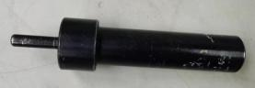

**Rear shock absorber indenter**

**Special tooling for this chapter:**

### engine case、transmission specification unit：mm

|  |  |  |  |  |
| --- | --- | --- | --- | --- |
| Item | | | Standard value | Maintenance threshold value |
| Transmission mechanism | Spindle | Shaft diameter | 20.002～20.015 | / |
|  |  | bearing | 19.992～20.000 | / |
| Bearing clearance | 0.002～0.023 | / |
| Output shaft | Shaft diameter | 25.077～25.095 | / |
| bearing | 25.000～25.015 | / |
| Bearing clearance | 0.062～0.095 | / |

### 22.2-Troubleshooting:

**gear shift gear**

* Gear wear
* Belt deformation

**Engine noise is too loud**

* The drive gear is worn or damaged
* Worn or damaged drive bearings

**22.3-Component location:**

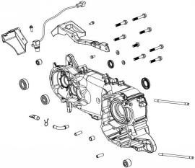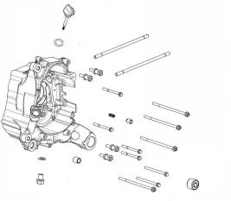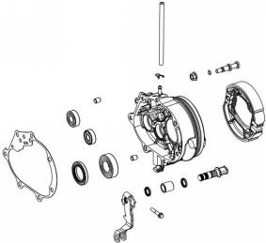

### 22.4-Transmission case/Transmission system

### **Removing the transmission case/drive system**

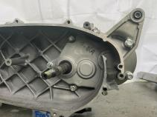

[1]

### 1.Remove left crankcase cover and CVT components.

2.Remove the transmission case fastening bolts [1]

3.Remove the transmission case part [1].

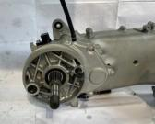

**[1]**

4.Take out the countershaft part [1] and the output shaft part [2] in sequence.

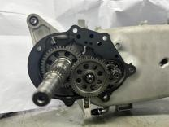

**[2]**

**[1]**

5.Remove the transmission case gasket [1] and locating pin [2].

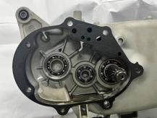

**[2]**

**[1]**

6.Use suitable tooling to remove the rear shock-absorbing sleeve, pay attention to the lower end face with suitable tooling to resist.

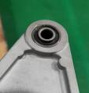

**[1]**

### **Note**: When disassembling the transmission case, pay attention to draining the transmission case oil.

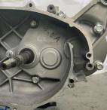

**Transmission case oil drain bolt**

### **Check**:

### Check the following parts for scratches, damage, abnormal wear or deformation.

### Replace if necessary.

### - sealing ring

### - oil seal

### -seal



**[1]**

### **Assembling the transmission case/transmission system**

### Press the rear shock absorber sleeve [1] into the installation hole of the left crankcase with the indenter tooling. After pressing, make sure that the outer end face of the installation hole is flush with the end face of the rear shock absorber sleeve.

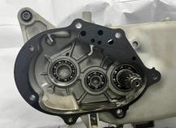

**[1]**

**[2]**

### Apply lubricating oil to the inner ring of the countershaft bearing and the output shaft bearing, and confirm whether the bearing rotates flexibly;

### Install the positioning pins and gaskets and check whether the parts of the transmission case are complete;

### Install the transmission box, and tighten the box closing bolts in sequence to the specified torque.

### **Check**:

### 1. Check whether the auxiliary shaft washer is complete, and assemble the auxiliary shaft and output shaft components;

### 2. Apply lubricating oil to the gear meshing position after assembly;

### 3. Check whether there is any movement of the output shaft, and each gear needs to be flexibly rotated.

### **Notice**:

* Check whether the output shaft moves, and each gear needs to rotate flexibly.
* The bearing washer is facing the side of the transmission case, and the movement of the output shaft is 0.1~0.6.

### **Torque: 20•m (20kgf•m, 14.74bf•ft)**

### 22.5-Engine case

**Dismantling the engine box**

1. Remove the box closing bolts from the right side.

**Notice:**

* Do not tap the crankshaft when dividing the box, and tap the craft hook on the box if necessary.

**Assembly**

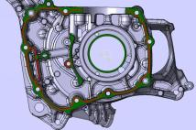

* Clean the left and right joint surfaces, taking care not to damage the joint surfaces. Check whether the oil passage is unobstructed, and clean the oil passage if necessary.

**Notice:**•

* Do not apply excess face sealant•
* Do not drop the sealant into the inside of the box
* Install the positioning pins, install the right crankcase on the left crankcase, install the closing bolts and tighten to the specified torque.



**Torque: 10N•m, 10kgf•m, 7.41bf•ft**

**As shown in the figure, apply sealant evenly on the joint surface of the right crankcase**

### 23-Crankshaft, pistons and blocks:

#### **23.1-Maintenance information:**

### **Overview**

### To maintain the crankshaft, cylinder block, pistons and connecting rods, the crankcase must be separated. Refer to the case part for the method of separating the crankcase. Be careful not to scratch or bruise it during maintenance. Use a plastic plug gauge when checking the lateral clearance of the connecting rod.

### Crankshaft, Piston and Block Specifications unit：mm

|  |  |  |  |  |  |
| --- | --- | --- | --- | --- | --- |
| Item | | | | Standard value | Maintenance threshold value |
| Crankshaft | Large end side clearance of connecting rod | | | 0.10～0.35 | 0.45 |
| Clearance between connecting rod big end bearing bush and crank pin | | | 0.097～0.127 | 0.07 |
| Journal runout | | | — | 0.05 |
| Pistons, Piston Pins, Piston Rings | Piston base circle diameter | | | 52.370～52.390 | 52.30 |
| Pin hole diameter | | | 15.002～15.008 | 15.04 |
| Piston pin diameter | | | 14.994～15.000 | 14.96 |
| Piston ring closed gap | | First ring | 0.10～0.30 | 0.35 |
| Second ring | 0.20～0.40 | 0.45 |
| Inner diameter of connecting rod small end | | | | 15.016～15.034 | 15.06 |
| Cylinder | | Diameter | | 57.9 | / |
| Bore | | 52.400～52.410 | 52.500 |

### 

### 23.2-Troubleshooting:

**Low cylinder pressure, difficult starting or poor low speed performance**•

●Air leakage of cylinder head gasket•

●Piston rings are worn, stuck or damaged•

●Cylinder head/piston worn or damaged

**The cylinder pressure is too high, the cylinder block is overheated, or the cylinder is knocked**•

●Excessive carbon deposits on the top of the piston or in the combustion chamber•

●The cam decompression mechanism fails

**Excessive exhaust**•

●Cylinder block, piston or piston ring wear• Incorrect assembly of piston rings•

●Piston or cylinder wall scratches

**Engine noise**•

●Piston pin or piston pin hole wear•

●The small end of the connecting rod is worn•

●Cylinder block, piston or piston ring wear•

●Crank pin bearing wear

**Engine vibration**

●Excessive crankshaft runout

### 23.3-Component layout:

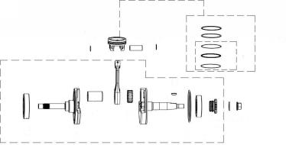

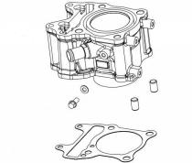

### 23.4-Cylinder block:

**Remove the cylinder**

1. Remove:

Cylinder Head

Clamps for components such as cooling pumps [1]

Water pipe[2]

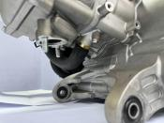

[1]

[2]

[3]

Chain tensioner plate (see valve train)

Cylinder block[3]

1. Use a rubber hammer and screwdriver to gently pry open the cylinder body and pull it out upwards;
2. Make the piston out of the cylinder hole and take out the

cylinder body.

**Check the cylinder**

●Check the cylinder body for scratches, damage, abnormal wear, deformation, burns, and blockage of oil passages.

●Measure all parts according to the specifications of the engine case, cylinder and drive train. If any part exceeds the maintenance limit, please replace it.

**Install the cylinder**

●Cylinder block installation and piston installation chapters are introduced together.

### 

### 23.5-Piston/Piston Ring:

### **Remove the piston**

### 1. After disassembling the cylinder block, place a clean cloth under the piston and use a suitable tool to remove the piston pin wire retaining ring;

1. 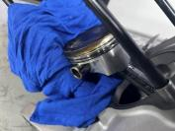Remove the piston pin with a suitable tool Remove the piston.

Do not reuse piston pin wire retainers. Demolition may weaken the springs, deform them, and they may fall and scratch the cylinder walls

**Notice**

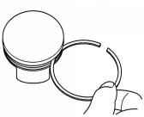

**Remove the piston ring**

1. Separate the ports of each piston ring and lift the ring up along the opposite side of the piston ring opening.

**Notice:**

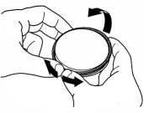

●Do not separate the ports too far to avoid damage to the piston rings. Be careful not to scratch the piston when removing the piston rings.

●Use the piston rings to be discarded to remove carbon deposits from the piston ring grooves.

●Do not use a steel brush to avoid scratching the piston ring.

**Check**

1. 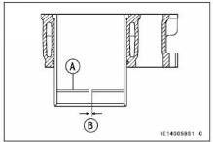Check the following components for scratches, damage, abnormal wear, deformation, burns, and blockage of oil passages.

-Cylinder block

-Piston

-Piston rings

-Piston pin

- connecting rod small end

1. Check the closed gap of the piston ring, put the piston ring A into the cylinder, and use the piston to locate the piston ring to the proper position.

* Set it near the bottom of the cylinder, where the cylinder wear is less.

1. Use a thickness gauge to measure the gap between the two ends of the ring [B] the closed gap of the piston ring.

* If the end play of any one ring exceeds the service limit, replace all piston rings.

1. Check the width of the piston ring groove and the thickness of the piston ring, and determine the gap between the piston ring and the ring groove. If the maintenance limit is exceeded, replace the new piston ring and measure again. If it is not qualified, replace the new piston.
2. Measure each component and calculate clearance based on crankshaft, piston and cylinder block specifications.

6. Replace any parts that are outside the maintenance limit.

**Assemble the piston rings**

1. 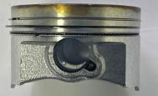Thoroughly clean the piston ring groove and install the piston ring;

[1]

[3.1]

[3.3]

[3.2]

[2]

1. Apply oil on the entire surface of the piston ring and the groove of the piston ring;

3. Put the open left end of the lining ring [3.1] into the oil ring groove, screw it into the oil ring groove smoothly, and install the oil ring [3.2] in the piston oil ring groove.

4. Put the open left end of the second lining ring [3.3] into the oil ring groove, and screw it into the oil ring groove smoothly. The two oil ring lining rings are installed on both sides of the oil ring respectively 90°, rotate the oil ring and the lining ring, and confirm whether the rotation is smooth and there is no sticking phenomenon.

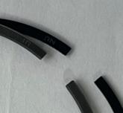

[2]

[1]

5. Put the lettering face up at the opening of the second ring [2], put the left end of the opening into the second ring groove, and screw it into the second ring groove smoothly. The second ring of the piston and the opening of the oil ring are misaligned by about 180°. Rotate the second ring to confirm that the rotation is flexible. , the piston is not scratched.

6. Put the lettering face up at the opening of the first ring [3], put the left end of the opening into the first ring groove, and screw it into the first ring groove smoothly. The first ring of the piston and the opening of the second ring are misaligned by about 180°. Rotate the first ring to confirm that the rotation is flexible,the piston is not scratched.

**Notice:**

**First ring (engraved with 1R)[1]**

**Second ring (engraved with RN)[2]**

**Assembly piston**

1. Clean the sealant on the joint surface of the cylinder block, and apply oil on the cylinder wall and the thrust surface of the piston;
2. Assemble the steel wire retaining ring on the left side of the piston in the piston ring groove first, and the opening is misaligned with the piston notch by 180︒;
3. Place the cylinder body on the platform in such a way that the joint surface of the cylinder body and the cylinder head faces downwards, and the joint surface of the cylinder body and the box faces upwards;
4. Install the piston guide sleeve on the cylinder block, put the piston head down into the cylinder block, pay attention to the piston "IN" marking towards the engine intake direction;
5. Apply sealant evenly to the sealing line of the sealing surface of the cylinder head, and pay attention to prevent the piston from coming out of the cylinder hole;
6. Assemble the cylinder-piston assembly on the box through the stud bolts. Be careful not to damage the sealant when assembling, and the tensioner mounting hole faces the air intake direction;
7. Apply lubricating oil on the surface of the piston pin, pass through the hole on the left side of the piston and the small end of the connecting rod to the hole on the right side of the piston;
8. Assemble the steel wire retaining ring on the right side of the piston in the piston ring groove, and the opening is 180︒ misaligned with the piston notch. Be careful that the piston wire retaining ring falls into the box;

9. Lightly tap the cylinder body towards the box body with a rubber hammer, install the cylinder body in place, the joint surface is in complete contact with the joint surface of the box body, and then assemble the cylinder head part.

