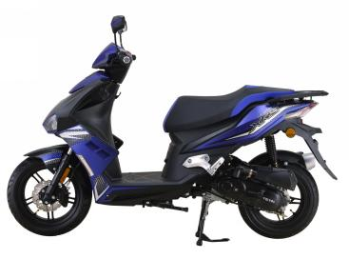

TY50QT-19D

SERVICE MANUAL

# C:\Users\w\Desktop\WPS图片.jpegWPS图片Foreword

This service manual contains the technical data of each component inspection and repair for the TY50QT-19D motorcycle. The manual is shown with illustrations and focused on "Service Procedures", “Operation Key Points”, and "Inspection Adjustment" so that provides technician with service guidelines.

If the style and construction of the motorcycle, TY50QT-19D, are different from that of the photos, pictures shown in this manual, the actual vehicle shall prevail. Specifications are subject to change without notice.

Zhejiang Tianying Locomotive Co., Ltd.

**I.General information**

01-The main technical parameters………………………3

02-Lubrication system specifications……………………4

03-Crankshaft, piston and cylinder specifications………4

04-Cylinder head and valve specifications………………5

05-Torque value……………………………………………6

06-Electrical device location map…………………………8

07-Service precautions……………………………………9

08-Troubleshooting………………………………………15

09-Lubrication points……………………………………19

**II.Maintenance information**

11-Air cleaner……………………...……………………...20

12-Steering handle top bearing……… …………………21

13-Cushion………………………………………………21

14-Schematic diagram of the braking system…………22

14.1-Precautions in operation…………………………23

14.2-Troubleshooting…………………………………24

14.3-Disc brake system inspection……………………25

14.4-Add brake fluid……………………………………26

14.5-Brake fluid replacement / Air-bleed………………27

14.6-Front brake caliper…………………………………28

14.7-Rear brake caliper…………………………………29

14.8-Brake disk…………………………………………30

14.9-Master cylinder……………………………………30 **III.Engine maintenance**

15-Main characteristics…………………………………33

16-Main technical specification…………………………33

17-Precautions for use…………………………………34

18-Regular maintenance project and schedule………36

1. **General information**

**01**-**The main technical parameters:**

|  |  |  |  |
| --- | --- | --- | --- |
| **Item** | **Technical parameters** | **Item** | **Technical parameters** |
| L×W×Hmm | 1930×665×1143 | Engine type | 1P39QMB, Single cylinder,  four stroke,  Forced air cooling,  cylinder horizontal type |
| Wheelbase mm | 1295 | Transmission type | CVT |
| Front wheel size | 130/60-13 | Transmission ratio | 2.64～0.86 |
| Rear wheel size | 120/70-12 | Compression ratio | 10.5:1 |
| Ground clearance mm | 150 | Bore diameter × stroke mm | 39×41.5 |
| Curb weight kg | 103 | Working volume ml | 49.5 |
| Max load kg | 150 | Clutch type | Automatic |
| Handlebar swivel angleº | ≤48 | Lubrication method | Pressure, pressure splash combined |
| Max speed km/h | 45 | Idle speed r/min | 1600±100 |
| Economic fuel consumption | 450 g/kW·h | Crankcase lubricating oil volume L | 0.7 |
| Climbing performance º | ≥13 | Lubricant grade | SF class 15W/40(crankcase) |
| Battery | 12V 7Ah | Ignition method | ECU Electronically controlled ignition |
| Fuel grade | Above RQ90 | transmission case oil volume L | 0.15 |
| Spark plug specifications | A7RTC | Gear oil grade | GL-4 85W/90 |
| Spark plug gap | 0.6～0.7mm | Fuse | 15 A |
| Gasoline volume L | 5 | Headlamps (High Beam) | LEDs×2 10W 12V |
| Front position light | LEDs×2 0.5W 12V | Headlamp (low beam) | LED×1 5W 12V |
| Front turn signal | LED\*8 1W 12V | Rear license plate lights | 12V W5W 5W |
| Rear turn signal | LED×9 0.36W 12V | Brake (brake) light | LED\*12 0.6W 12V |
| Rear tail light | LED\*12 0.24W 12V |

**02-Lubrication system specifications:** unit: mm

|  |  |  |  |
| --- | --- | --- | --- |
| **Item** | | **Standard value** | **Maintenance threshold** |
| Engine oil capacity | change engine oil | 0.8 L | - |
| after removing the engine | 0.9 L | - |
| 80W-90 Gear Oil | change gear oil | 0.12 L | - |
| after removing the engine | 0.2 L | - |
| Recommended engine oil | | Recommended engine oil: SF15W-40  API Quality Grade: SG or higher (do not use oils marked as energy efficient on the circular API service label) | - |
| Engine oil pump rotor | Tip clearance | Not more than 0.15 (between inner and outer rotors) | 0.16 |
| Intermediate gap | 0.016～0.074 (inner rotor hole and shaft) | 0.084 |
| Gap on both sides | 0.06 to 0.12 (up and down direction) | 0.13 |

**03**-**Crankshaft, piston and cylinder specifications:** unit: mm

|  |  |  |  |  |
| --- | --- | --- | --- | --- |
| **Item** | | | **Standard value** | **Maintenance threshold** |
| Crankshaft | Large end side clearance of connecting rod | | 0.10～0.35 | 0.45 |
| Clearance between connecting rod big end bearing bush and crank pin | | 0.004～0.012 | 0.07 |
| Beat | | - | 0.05 |
| Cylinder block | Bore | | 39.000～39.010 | 39.120 |
| Out-of-roundness | | - | 0.05 |
| Taper | | - | 0.05 |
| Flatness | | - | 0.05 |
| Pistons, Piston Pins, Piston Rings | Piston base circle diameter | | 38.975～38.98 | 38.95 |
| Pin hole diameter | | 13.002～13.008 | 13.02 |
| Piston pin diameter | | 12.994～13 | 12.98 |
| Piston to Piston Pin Clearance | | 0.002～0.014 | 0.02 |
| Piston ring closed gap | First ring | 0.10～0.30 | 0.35 |
|  | Second ring | 0.20～0.40 | 0.45 |
| Oil ring (scraper ring) | 0.20～0.70 | 0.9 |
| Piston ring and ring groove clearance | Clearance between first ring and groove | 0.020～0.060 | / |
| Gap between second ring and groove | 0.020～0.060 | / |
| Cylinder clearance | | | 0.010～0.045 | 0.10 |
| Inner diameter of connecting rod small end | | | 13.01～13.02 | 13.12 |
| Fitting clearance between connecting rod and pin | | | 0.016～0.040 | 0.06 |

**04**-**Cylinder head and valve specifications:** unit: mm

|  |  |  |  |  |
| --- | --- | --- | --- | --- |
| **Item** | | | **Standard value** | **Maintenance threshold** |
| Electric start cylinder pressure | | | (800～1000)kPa | **-** |
| Valve clearance | | Intake valve | 0.06～0.08 | **-** |
| Exhaust valve | 0.14～0.16 | **-** |
| Rocker arm, rocker arm shaft | Rocker arm inner diameter | Intake/exhaust | 10～10.015 | 10.030 |
| Rocker bearing outer diameter | Intake/exhaust | / | / |
| Rocker arm and bearing | Intake/exhaust | / | / |
| Gap | Intake/exhaust | / | / |
| Rocker bearing inner diameter | Intake/exhaust | 9.978～9.988 | 9.962 |
| rocker shaft outer diameter | Intake/exhaust | / | / |
| Camshaft | Camshaft hull height | Intake | 25.736～25.786 | 25.726 |
| Exhaust | 25.55～25.6 | 25.54 |
| Bearing and bore clearance | | 0.002～0.026 | 0.036 |
| Beat | | / | / |
| Valve/vale catheter | Valve stem diameter | Intake | 4.975～4.99 | 4.965 |
| Exhaust | 4.955～4.97 | 4.945 |
| Valve guide inner diameter | Intake/exhaust | 5～5.012 | 5.022 |
| Valve stem to valveduct gap | Intake | 0.01～0.037 | 0.057 |
| Exhaust | 0.03～0.057 | 0.077 |
| Catheter height (leakage) | Intake/exhaust | 9.6～10 | / |
| Valve seat width | Intake/exhaust | 1.0～1.2 | 1.6 |
| Valve spring free length | | Inside diameter | 30.3～30.7 | / |
| Inside diameter | 33.9～34.3 | / |
| Cylinder head flatness | | 0.05 | | 0.05 |

**05**-**Torque values:**

The torque values listed in below are for more important tightening torque values. Please see standard values for those not listed in the table.

Standard torque values for reference:

|  |  |  |  |
| --- | --- | --- | --- |
| **Type** | **Tighten torque** | **Type** | **Tighten torque** |
| 5 mm bolt、nut | 0.45~0.6kgf.m | 5 mm screw | 0.35~0.5kgf.m |
| 6 mm bolt、nut | 0.8~1.2kgf.m | 6 mm screw、SH nut | 0.7~1.1kgf.m |
| 8 mm bolt、nut | 1.8~2.5kgf.m | 6 mm bolt、nut | 1.0~1.4kgf.m |
| 10 mm bolt、nut | 3.0~4.0kgf.m | 8 mm bolt、nut | 2.4~3.0kgf.m |
| 12 mm bolt、nut | 5.0~6.0kgf.m | 10 mm bolt、nut | 3.5~4.5kgf.m |

Engine torque value (regular maintenance):

|  |  |  |  |  |
| --- | --- | --- | --- | --- |
| **Item** | **Quantity** | **Thread diameter (mm)** | **Torque value (N.m)** | **Re mark** |
| Spark plug | 1 | 10 | 12～15 |  |
| Valve cover | 1 | 30 | 20～25 | Strainer cover |
| Sealing plug | 1 | 12 | 25～30 | Crankcase oil drain bolt |
| Transmission case oil drain bolt | 1 | 8 | 18～22 | With gasket |
| Transmission case refueling bolt | 1 | 8 | 18～22 | With gasket |

|  |  |  |  |  |
| --- | --- | --- | --- | --- |
| **Item** | **Quantity** | **Thread diameter (mm)** | **Torque value (N.m)** | **Re mark** |
| Cylinder head nut | 4 | 8 | 28～32 | Oil on the nut end |
| Camshaft flapper bolt | 1 | 6 | 8～12 |  |
| Valve rocker shaft bolt | 2 | 5 | 5～9 |  |
| Oil and gas separation plate screw | 4 | ST4.2 | 2～3 |  |
| Cylinder head bolts | 4 | 6 | 8～12 |  |
| Cylinder head cover see oil bolt | 1 | 5 | 8～12 |  |
| Tensioner adjusting bolt | 1 | 6 | Hand tighten |  |
| Cylinder connecting bolt | 2 | 6 | 8～12 |  |

Cylinder head and valve:

Belt combination:

|  |  |  |  |  |
| --- | --- | --- | --- | --- |
| **Item** | **Quantity** | **Thread diameter (mm)** | **Torque value (N.m)** | **Re mark** |
| Main drive pulley tightening nut | 1 | 14 | 63～77 | Auxiliary tooling required |
| Driven pulley tightening nut | 1 | 12 | 43～53 | Auxiliary tooling required |
| Left crankcase cover bolts | 10 | 6 | 8～12 |  |

Magneto:

|  |  |  |  |  |
| --- | --- | --- | --- | --- |
| **Item** | **Quantity** | **Thread diameter (mm)** | **Torque value (N.m)** | **Re mark** |
| Magneto rotor bolts | 1 | 12 | 80～90 | Apply 1262 thread glue |
| Magneto stator bolts | 3 | 6 | 18～12 |  |
| Hall sensor bolt | 1 | 6 | 7～9 | Apply 1262 thread glue |
| Trigger fixing bolt | 2 | 6 | 8～12 |  |
| Clamping plate bolts | 2 | 6 | 8～12 |  |
| Right crankcase cover bolts | 10 | 6 | 8～12 |  |

Case and transmission system:

|  |  |  |  |  |
| --- | --- | --- | --- | --- |
| **Item** | **Quantity** | **Thread diameter (mm)** | **Torque value (N.m)** | **Re mark** |
| Crankcase bolts | 10 | 6 | 8～12 |  |
| Crankcase positioning stud | 4 | 6 | 8～12 |  |
| Transmission case bolts | 7 | 8 | 18～22 |  |
| Pin lock nut | 1 | 8 | 18～22 | transmission case brake drum locating pin |
| Rear brake camshaft limit bolt | 1 | 6 | 8～12 | Rear brake arm |
| Press pin body tightening bolt | 1 | 6 | 8～12 | Timing chain limit plate fastening |
| Fastening bolt for speed sensor | 1 | 6 | 8～12 |  |
| Speed sensor protection board, lower | 2 | 6 | Hand tighten |  |

# 电器位置06-Electrical device location map:

**07**-**Service precautions:**

* Always use genuine parts and recommended oil.Using improper parts may cause damage to or

**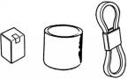** destruction of the vehicle.

* Special tools are designed for removal and installation of component parts without damaging them. Using wrong tools may result in parts damage.

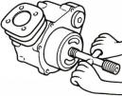

* When servicing this vehicle, use only metric tools. Metric bolts, nuts, and screws are not interchangeable with the Britain system, using wrong tools and fasteners may damage this vehicle.
* Clean the outside of the parts or the cover before removing it from the vehicle. Otherwise, dirt and deposit accumulated on the part's surface may fall into the engine, chassis, or brake

system to cause damage.

* Wash and clean parts with high flash point solvent, and then blow dry with compressed air. Pay special attention to O-rings or oil seals because most of the cleaning agents have bad effect

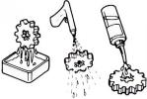on them.

* Never bend or twist control cables to avoid unsmooth control and premature worn out.

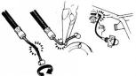

* Rubber parts may become deteriorated when old, and be damaged by solvent and oil easily. Check these parts before installation to make sure that they are in good condition, replace if necessary.
* When loosening a component which has different sized fasteners, operate with a diagonal pattern and work from inside out. Loosen the small fasteners first. If the bigger ones are loosen first, small fasteners may receive too much stress.
* Store complex components such as transmission parts in the proper assemble order and tie them together with a wire for ease of installation later.

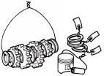

* Note the reassemble position of the important components before disassembling them to ensure they will be reassembled in correct dimensions (depth, distance or position).
* Components not to be reused should be replaced when disassembled including gaskets metal seal rings, O-rings, oil seals, snap rings, and split pins.

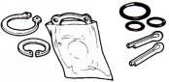

* The length of bolts and screws for assemblies, cover plates or boxes is different from one another, be sure they are correctly installed. In case of confusion, Insert the bolt into the hole to compare its length with other bolts, if its length out side the hole is the same with other bolts, it is a correct bolt. Bolts for the same assembly should have the same length.

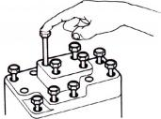

* 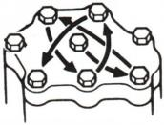Tighten assemblies with different dimension fasteners as follows: Tighten all the fasteners with fingers, then tighten the big ones with special tool first diagonally from inside toward outside, important components should be tightened 2 to 3 times with appropriate increments to avoid warp unless otherwise indicated. Bolts and fasteners should be kept clean and dry. Do not apply oil to the threads.
* When oil seal is installed, fill the groove with grease, install the oil seal with the name of the manufacturer facing outside, and check the shaft on which the oil seal is to be installed for smoothness and for burrs that may damage the oil seal.

**Manufacturer's name**

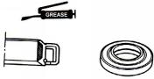

* Remove residues of the old gasket or sealant before reinstallation, grind with a grindstone if the contact surface has any damage.

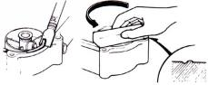

* The ends of rubber hoses (for fuel, vacuum, or coolant) should be pushed as far as they can go to their connections so that there is enough room below the enlarged ends for tightening the clamps.

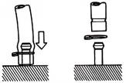

Groove

Clamp

Connector

* Rubber and plastic boots should be properly reinstalled to the original correct positions as designed.

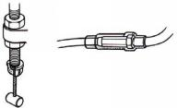

**Boots**

* 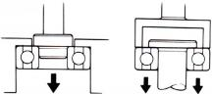The tool should be pressed against two (inner and outer) bearing races when removing a ball bearing. Damage may result if the tool is pressed against only one race (either inner race or outer race). In this case, the bearing should be replaced. To avoid damaging the bearing, use equal force on both races.

**Both of these examples can result in bearing damage.**

* Lubricate the rotation face with specified lubricant on the lubrication points before assembling.



* Check if positions and operation for installed parts is in correct and properly.

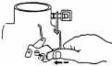

* Make sure service safety each other when conducting by two persons.

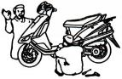

* Note that do not let parts fall down.



* Before battery removal operation, it has to remove the battery negative (-) cable firstly. Notre tools like open-end wrench do not contact with body to prevent from circuit short and create spark.

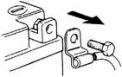

* After service completed, make sure all connection points is secured.Battery positive (+) cable should be connected firstly
* And the two posts of battery have to be greased after connected the cables.

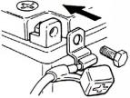

* Make sure that the battery post caps are located in properly after the battery posts had been serviced.

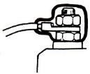

* If fuse burned, it has to find out the cause and solved it. And then replace with specified capacity fuse.

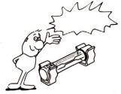

**Capacity verification**

* When separating a connector, it locker has to be unlocked firstly；Then, conduct the service operation.



* Do not pull the wires as removing a connector or wires；Hold the connector body.



* Make sure if the connector pins are bent, extruded or loosen.
* Insert the connector completely.If there are two lockers on two connector sides, make sure the lockers are locked in properly.Check if any wire loose.
* Check if the connector is covered by the twin connector boot completely and secured properly.



* Before terminal connection, check if the boot is crack or the terminal is loose.



* Insert the terminal completely.Check if the terminal is covered by the boot. Do not let boot open facing up.



* Secure wires and wire harnesses to the frame with respective wire bands at the designated locations. Tighten the bands so that only the insulated surfaces contact the wires or wire harnesses.

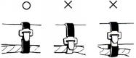

* 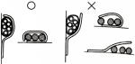Wire band and wire harness have to be clamped secured properly.
* Do not squeeze wires against the weld or its clamp.



* Do not let the wire harness contact with rotating, moving or vibrating components as routing the harness.

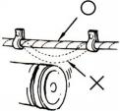

* Keep wire harnesses far away from the hot parts.

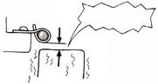

**Never Touch**

* Route wire harnesses to avoid sharp edges or corners and also avoid the projected ends of bolts and screws.

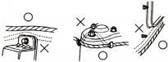

* Route harnesses so that they neither pull too tight nor have excessive slack.

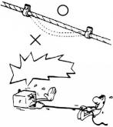

**Never too tight**

* 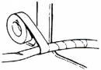Protect wires or wire harnesses with electrical tape or tube if they contact a sharp edge or corner. Thoroughly clean the surface where tape is to be applied.
* 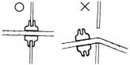Secure the rubber boot firmly as applying it on wire harness.
* Never use wires or harnesses which insulation has been broken.Wrap electrical tape around the damaged parts or replace them.

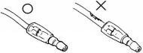

* Never clamp or squeeze the wire harness as installing other components.

**Never clamp or squeeze the wire harness**

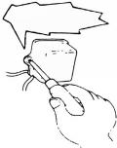

* Do not let the wire harness been twisted as installation.

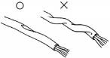

* Wire harnesses routed along the handlebar should not be pulled too tight or have excessive slack, be rubbed against or interfere with adjacent or surrounding parts in all steering positions.

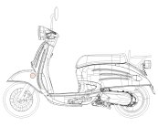

* Before operating a test instrument, operator should read the operation manual of the instrument. And then, conduct test in accordance with the instruction.

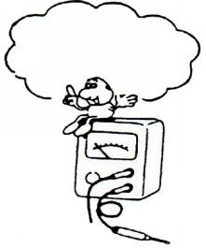

**Do you know how to set the instrument to its measurement position and the insert locations of its two probes?**

* With sand paper to clean rust on connector pins/terminals if found. And then conduct connection operation later.

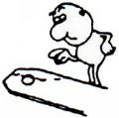

**Clean rust**

**08**-**Troubleshooting:**

1. **Engine cannot be started or difficult to be started**

**Probable causes**

**Check and adjustment**

**Check and adjustment**

**The fuel supply to the fuel injector is sufficient**

**Press the fuel injector feed pipe and confirm whether there is fuel in the feed pipe**

**The fuel injector is not**

**Check the spark plug ignition condition**

**Week sparks or no spark**

**Sparks**

**Perform cylinder compression pressure test**

**2.Check if the fuel pipe and the vacuum**

**tube are blocked or not**

**cuvavacuumvacuum**

**3.Malfunction of fuel pump relay or wiring**

**5.The fuel strainer is blocked or not**

**4.Malfunction of fuel pump**

**2.Malfunction of throttle valve operation**

**1.Contaminated or clogged fuel injector**

**2.Malfunction of fuel pressure regulator**

**Wet spark plug**

**Dry spark plug**

**1.Malfunction of throttle valve operation**

**3.Incorrect ignition timing**

**2.Air sucked into intake manifold**

**With signs of ignition but the engine cannot be started**

**No ignition**

**5.Ignition coil is in open or short circuit**

**6.Malfunction of main switch**

**4.Malfunction of the AC Generator**

**3.Malfunction of ECU**

**2.Spark plug contamination**

**1.Malfunction of spark plug**

**2.Malfunction of cylinder valves**

**4.Cylinder gasket leakage**

**3.Worn cylinder and piston ring**

**5.Sand hole in the compression parts**

**1.Piston ring seized**

**Low or no compression pressure**

**1.Check the fuel amount in the fuel tank**

**Normal cylinder compression pressure**

**Restart the engine**

**Remove and check the spark plug**

1. **Engine runs sluggish (Speed does not pick up, lack of power)**

**Fault condition**

**Fault condition**

**Accelerate gradually and  
 check engine RPM**

**Check and adjustment**

**1.Clogged air cleaner**



**Normal**

**Continually drive in acceleration or high speed**

**Engine RPM can be increased**

**Abnormal compression pressure**

**3.Poor fuel quality**

**4.Abnormal ignition timing**

**2.Malfunction of fuel injector**

**1.Carbon deposit in the combustion chamber**

**4.Carbon deposit in the combustion chamber**

**3.Poor fuel quality**

**2.Abnormal fuel injector**

**1.Worn out piston or cylinder**

**1.Incorrect spark plug heat range**

**1.Remove the dirt**

**1.Replace the fuel injector**

**4.Valve deterioration**

**3.Sand hole in compression parts**

**5.Jammed piston ring**

**2.Cylinder gasket leakage**

**1.Worn out cylinder or piston ring**

**1.Malfunction of ECU**

**2.Malfunction of AC Generator**

**4.Clogged fuel injector**

**3.Clogged exhaust pipe**

**2.Poor fuel supply**

**No knocking**

**Knocking**

**Check cylinder compression pressure (using compression**

**Engine overheated**

**Check if the engine is over heated**

**No contamination or**

**contamination or**

**Remove and check the spark plug**

**clogged**

**Not clogged**

**Check if the fuel injector is clogged or not**

**Normal compression pressure**

**Incorrect ignition**

**Correct ignition timing**

**Check ignition timing (Using ignition lamp)**

**Engine RPM cannot be increased**

1. **Engine runs sluggish (especially in low speed and idling)**

**Probable causes**

**Fault condition**

**Check and adjustment**

**Check ignition timing (using ignition lamp)**

1. **Incorrect ignition timing**

**(malfunction of ECU or AC）**

**Normal**

**Abnormal**

**Check for any air sucked in through the throttle body insulator gasket**

**1.Abnormal throttle body insulator gasket**

**4.Damaged ABV pipe**

**3.Abnormal inlet pipe gasket**

**2.Abnormal throttle body installation**

**Air sucked in**

**No air sucked in**

**Remove the spark plug and check the spark condition**

**1.Contaminated spark plug**

**3.Malfunction of AC Generator**

**2.Malfunction of ECU**

**4.Malfunction of ignition coil**

**Good spark**

**Poor spark**

**5.Open or short circuit in spark plug leads**



**6.Malfunction of main switch**

1. **Engine runs sluggish (High speed)**



**Fault condition**

**Probable causes**

**Poor**

**Good**

**Check the fuel pump supply condition**

**Check if fuel injector clogged supply condition**

**Clogged**

**Normal**

**1.Replace the fuel injector**

**Abnormal**

**Normal**

**Check ignition timing**

**1.Insufficient fuel in the fuel tank**

**2.Pressed or clogged fuel pipe**

**1.Malfunction of ECU**

**2.Malfunction of AC Generator**

**Check and adjustment**

1. **CLUTCH AND DRIVING PULLEY**

**Engine can be started but the vehicle cannot run**

**FAULT CONDITION**

**PROBABLE CAUSES**

**1.Worn out or damaged drive belt**

**2.Damaged movable drive face**

**3.Damaged driven face spring**

**4.Broken clutch weight**

**5.Broken drive shaft groove**

**6.Worn out or damaged transmission gear**

**1.Broken clutch spring**

**Engine shuts down or trembles when the vehicle is running (rear wheel rotates during engine idling)**

**2.Clutch outer stuck with clutch weights**

**3.Connection parts between clutch and shaft worn out or burned**

**1.Worn or deformed drive belt**

**Poor initial driving (poor climbing performance)**

**2.Worn weight roller**

**3.Worn driven face**

**4.Deformed driven face spring**

**5.Grease on drive belt or drive / driven**

### 09-Lubrication points:

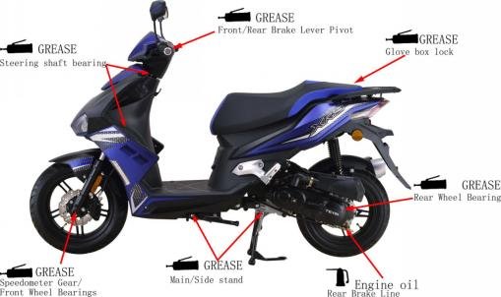

1. **Maintenance Information**

**11-Air Cleaner:**

1. Remove 6 screws from the air cleaner cover and then remove the cover;

**6 screws**

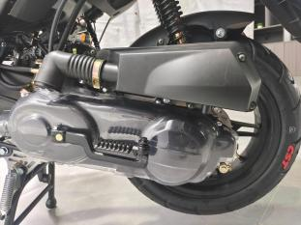

1. Remove the air cleaner element;

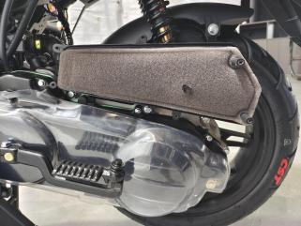

**Air filter element**

3.Clean air cleaner element:

Use compressed air to remove the adhesion of dirt,if too much dirt , please new replacement.

 **Caution**

* The air filter element is made of paper products, must not soak or cleaning by water.

### 12-Steering handle top bearing:

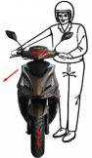

**Caution**

* Lift the front wheel out of ground；
* Check all wires and cables if they are interfered with the rotation of steering handle bar.
* Turn handle from right to left alternative and check if turning is smoothly；
* If handle turning is uneven and bending, or the handle can be operated in vertical direction, then adjust the handle top bearing.

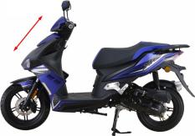

**13**-**Cushion:**

 **Caution**

**Front cushion:**

* Do not ride the motorcycle with poor cushion.
* Looseness, wear or damage cushion will make poor stability and drive-ability.
* Press down the front cushion for several times to check it operation；
* 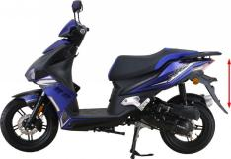Check if it is damage Replace relative parts if damage found；
* Tighten all nuts and bolts

**Rear Cushion:**

* Press down the front cushion for several times to check it operation；
* Check if it is damage Replace relative parts if damage found；
* Park motorcycle with main stand；
* Turn the rear wheel forcefully and check if engine bracket bushing worn out Replace the bushing if looseness found；
* Tighten all nuts and bolts.

### 14-Schematic diagram of the braking system:

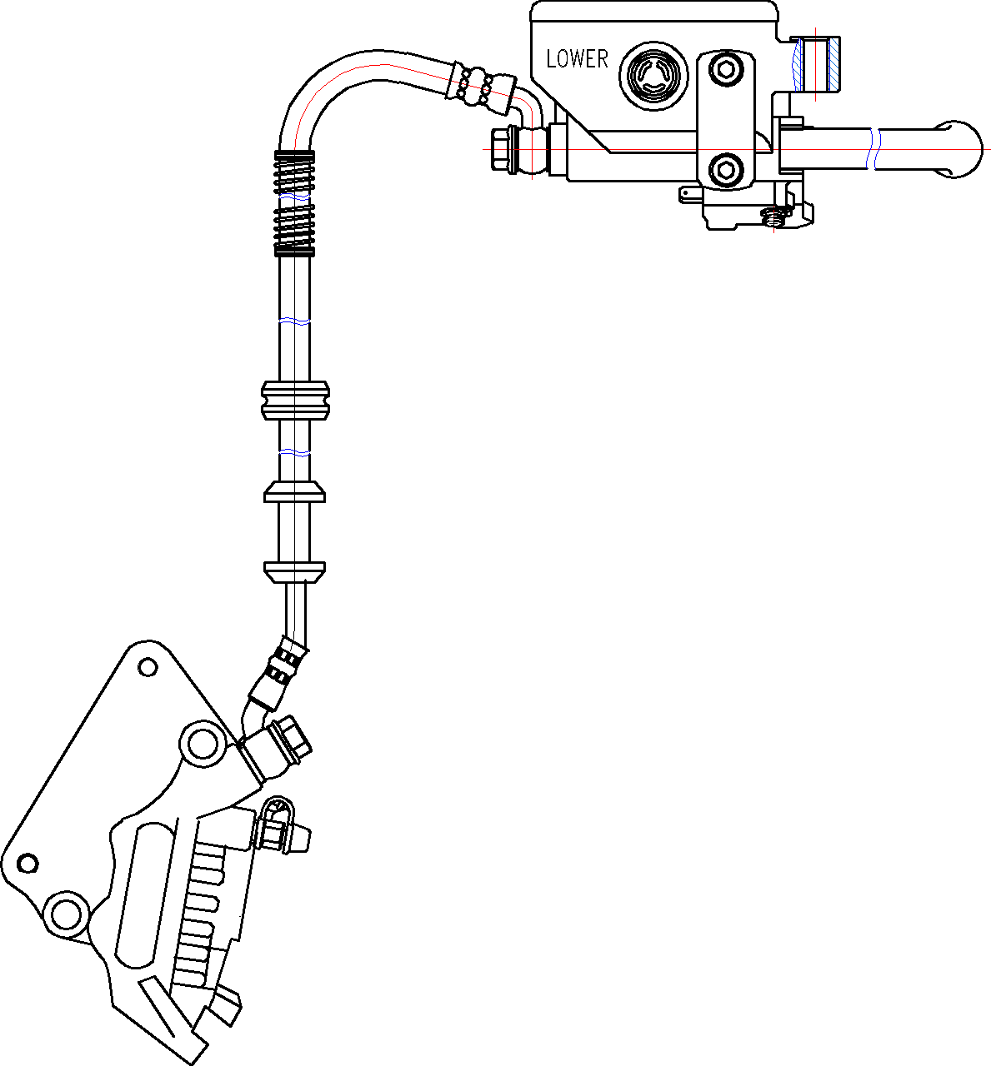

### 14.1-Precautions in operation:

 **Caution**

* Inhaling asbestos may cause disorders of respiration system or cancer, therefore, never use air hose or dry brush to clean brake parts. Use vacuum cleaner or other authorized tool instead.
* The brake caliper can be removed without removing the hydraulic system；
* After the hydraulic system is removed, or the brake system is felt to be too soft, bleed the hydraulic system；
* While refilling brake fluid, care should be taken not to let the foreign material entering into the brake system；
* Do not spill brake fluid on the painted surfaces, plastic or rubber parts to avoid damage；
* Check the operation of the brake system before riding.

**Specifications** unit: mm

|  |  |  |
| --- | --- | --- |
| Item | Standard | Limit |
| The thickness of front brake disk | 4.000 | 2.500 |
| The thickness of rear brake disk | / | / |
| Front and rear brake disk eccentricity | < 0.100 | 0.300 |
| Front brake master cylinder inner diameter | 12.7+0.055 0 | 12.765 |
| Front brake master cylinder piston outer diameter | 12.7+0.055 0 | 12.765 |
| Rear brake master cylinder inner diameter | / | / |
| Rear brake master cylinder piston outer diameter | / | / |
| Diameter of front disk | 190.000 | / |
| Diameter of rear disk | / | / |
| Thickness of front brake lining | 5.000 | 2.000 |
| Thickness of rear brake lining | / | / |

##### Torque values:

Brake hose bolts： 3.0~4.0kgf.m

Bolt for front brake caliper： 2.9~3.5kgf.m

Brake lever nut： 0.8~1.0kgf.m

Air-bleed valve： 0.8~1.0kgf.m

### 14.2-Troubleshooting:

##### Soft brake lever:

1. Air inside the hydraulic system
2. Hydraulic system leaking
3. Worn master piston
4. Worn brake pad
5. Poor brake caliper
6. Worn brake lining/disk
7. Low brake fluid
8. Blocked brake hose
9. Warp/bent brake disk
10. Bent brake lever

##### Hard operation of brake lever:

1. Blocked brake system
2. Poor brake caliper
3. Blocked brake pipe
4. Seized/worn master cylinder piston
5. Bent brake lever

##### Uneven brake:

1. Dirty brake lining/disk
2. Poor wheel alignment
3. Clogged brake hose
4. Deformed or warped brake disk
5. Restricted brake hose and fittings

##### Tight brake:

1. Dirty brake lining/disk
2. Poor wheel alignment
3. Deformed or warped brake disk

##### Brake noise:

1. Dirty lining
2. Deformed brake disk
3. Poor brake caliper installation
4. Imbalance brake disk or wheel

### 14.3-Disk brake system inspection:

##### Inspection:

* By visual examination whether divulges or the damage, with spanner inspection brake tube seam whether becomes less crowded, and the inspection handle bar turn right or turn left, or pressure the cushion, whether besides the pipeline protection department, whether there is interferes, contacts other parts of；

**Brake linings wear limit grooves**

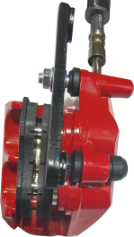

* Remove the front brake pad cap；
* Check the brake from behind the brake caliper；

**Brake caliper Brake disk**

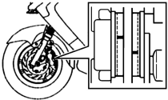

* The brake pad must be replaced with new lining when the brake pad wear limit reaches the brake disk；
* Park the motorcycle on a level ground, and check if fluid level is under the “LOWER” mark；
* Recommended Brake Fluid:

WELL RUN BRAKE OIL (DOT 3)

Disc brake pump

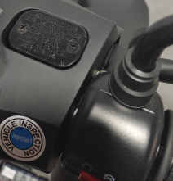 **Caution**

* The vehicles inclined or just stop, the survey oil level could not be accurate, had to settle the 3~5 minute；
* In order to prevent has the chemical change, please do not use counterfeiting or other unclear trade marks brake fluid；
* Standard brake fluid must be used to ensure the efficiency of braking.

**14.4**-**Add brake fluid:**

**Front brake master cylinder**

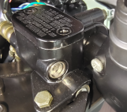

* Before the brake fluid reservoir is removed, turn the handle so that the brake fluid reservoir becomes horizontal, and then remove the brake fluid reservoir.
* When maintenance brake system, will be supposed to paint the surface or the rubber parts catches up by the rags.

 **Caution**

* Supplement brake fluid please do not surpass the upper limit, spilled brake fluid on painted surfaces, plastic or rubber components may result in their damages.
* Remove the master cylinder cap and diaphragm;

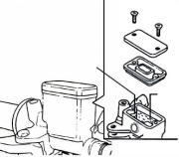

**Master cylinder cap**

**Diaphragm Upper level**

**Brake Fluid**

* Increases the high quality brake fluid, uses by all means must with the trade mark brake fluid joins in the master cylinder;
* Clean the dirty brake disk.

 **Caution**

* Dirty brake fluid will reduce braking performance.
* To mixed non-compatible brake fluid will reduce brake performance.
* Foreign materials will block the system causing brake performance to be reduced or totally lost.

### 14.5-Brake fluid replacement/Air-bleed:

1. Connect drain hose to air-bleed valve；

**Air-bleed valve**

**Front disc brake pump**

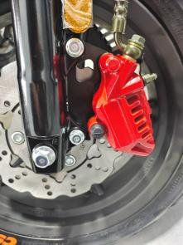

1. Open the drain valve on the calipers and delay valve the brake lever until the old brake fluid is entirely drained out；
2. Close the drain valve and add specified brake fluid into the brake master cylinder.

Recommended brake fluid:

WELLRUN DOT 3 brake fluid

1. Connect one end of transparent hose to the drain valve, and put the other end into a container；

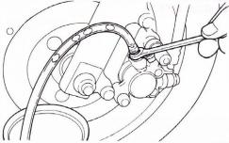

**Transparent hose**

**Air-bleed valve**

**Bubble**

1. Open the drain valve around 1/4 turns, and at the same time hold the brake lever until the there is no air bubble in the drain hose and also feeling resistance on the brake lever；
2. Close the drain valve when finishing the brake

system refilling fluid procedure, and operate the brake lever to check whether air bubble is in brake system or not；

7.If brake is still soft, please bleed the system as described below:

7.1.Tightly hold the brake lever and open the drain valve around 1/4 turns, and then close the valve；

7.2.Slowly release the brake lever, and wait for a few seconds until it reaches its top position；

7.3.Repeat the steps 1 and 2 until there is no air bubble at the end of the hose；

7.4.Tightly close the drain valve；

7.5.Make sure the brake fluid is in the UPPER level of the master cylinder, and refill the fluid if necessary；

7.6.Cover the cap. **Caution**

* Do not release the brake lever before the drain valve is closed.
* Always check the brake fluid level when carrying out the air bleeding procedure to avoid air enter into the system.

 **Caution**

* Discharge air from the lower pump;
* The brake fluid can be replaced by machine, with shorter time and less bubbles.

### G:\0-TLJ\工作文件\欧陆\欧陆50CC欧五电喷维修手册前碟后鼓\IMG_20230517_142733.jpgIMG_20230517_14273314.6-Front brake caliper:

C**aliper mounting bolts**

##### Removal:

* Remove two mounting bolts and caliper.

##### Installation:

* Install the brake caliper and tighten the mounting bolts.

Torque: 2.9~3.5kgf.m

 **Caution**

* Use M8 x 35 mm flange bolt only.
* Long bolt will impair the operation of brake disk.

**Cotter pins**

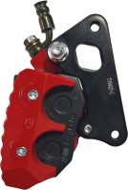

##### Brake pad replacement:

* Remove brake caliper;
* Remove Cotter pins;
* Remove brake pads;
* Install the Elastic reed;
* Install the new Brake pad;
* Tighten the Cotter pins.

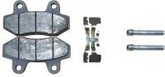

Brake pad

**Cotter pins**

**Elastic reed**

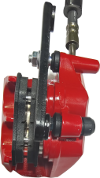

**Elastic reed**

### 14.7-Rear drum brake:

Rear brake cable adjustment nut

##### Removal:

* Release the rear brake cable adjusting nut, so that the brake rocker arm is in a relaxed state;
* Remove the rear wheel nut and Bolts shown，Then remove the rear wheel;

Rear brake cable adjustment nut×1

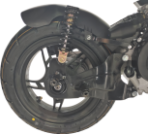

* Remove the rear brake shoe assembly.

##### Installation:

* Install the rear brake shoe block assembly;
* Install the rear wheel and rear wheel nuts;

Torque: 10.2-13.8kgf.m

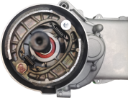

Rear brake shoe assy

* Install the rear brake cable adjusting nut and adjust the brake rocker arm to proper position.

 **Caution**

* When the brake rocker arm is adjusted to the limit position, the rear wheel brake is weak or the braking distance increases, please replace the rear brake shoe。 assembly immediately.



Wear limit

##### Rear brake shoe assembly replacement:

* Check the friction plate. If it exceeds the wear limit, replace it with a new rear brake shoe assembly.

### 14.8-Brake Disk:

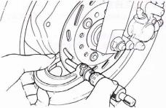

**Brake disk**

**Micrometer**

##### Inspection:

* Visually check the brake disk for wear or break.
* Measure the thickness of the disk at several places.
* Replace the disk if it has exceeded the service limit.
* **Allowable limit:**

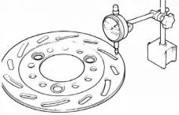

**Front brake disk:2.5mm**

* Remove the brake disk from wheel.

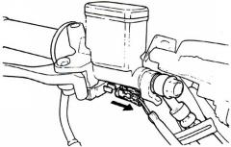

**Brake hose**

**Brake switch**

* Check the disk for deformation and bend.

**Allowable limit:0.30 mm**

 **Caution**

* The dirty brake lining or disk will reduce the brake performance.
* Brake lining includes the asbestos ingredient, cannot use the air-gun to be clean, the operator should dress the mouthpiece and the glove, use vacuum cleaner clean it.

### 14.9-Master Cylinder：

##### Master Cylinder Removal:

**** **Caution**

* Do not let foreign materials enter into the cylinder.

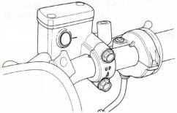

**2 bolts**

 **Caution**

* The whole set of master cylinder, piston, spring, diaphragm and cir clip should be replaced as a set.
* Remove the handlebar covers；
* Remove the leads of brake light switch；
* Drain out the brake fluid；
* Remove the brake lever from the brake master cylinder；

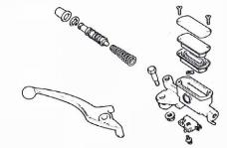

**Master cylinder**

**Spring**

**Piston**

**Piston**

**Cir clip**

**Rubber boot**

* Remove the brake hose；
* Remove the master cylinder bolts and the master cylinder.
* Remove the rubber pad；
* Remove the cir clip；
* Remove the piston and the spring；
* Clean the master cylinder with recommended brake fluid.

##### Master Cylinder Inspection：

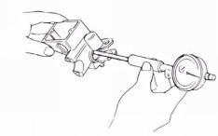

**Master cylinder**

* Check the master cylinder for damage or scratch，Replace it if necessary；
* Measure the cylinder inner diameter at several points along both X and Y directions；
* Replace the cylinder if the measured values exceed allowable limit.
* Allowable limit:

**Front brake:12.755 mm**

**Measure the outer diameter of the piston：**

**Master cylinder piston**

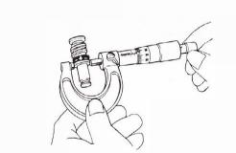

* Replace the piston if its measured value exceeds allowable limit.
* Allowable limit:

**Front brake: 12.645 mm**

**Master Cylinder Assembly：**

**Caution**

* It is necessary to replace the whole set comprising piston, spring, piston cup, and cir clip.
* Make sure there is no dust on all components before assembling.
* Apply clean brake fluid to the piston cup, and then install the cup onto the piston；



**Master cylinder**

**Spring**

**Piston**

**Piston**

**Cir clip**

**Rubber boot**

* Install the larger end of the spring onto the master cylinder；
* The master cup’s cavity should be face inside of master cylinder when installing the master cup；
* Install the cir clip.

 **Caution**

* Never install cup lip in the opposite direction.
* Make sure the cir clip is seated securely in the groove.

##### Master Cylinder Install：



**2 bolts**

* Install the rubber pad into the groove correctly；
* Place the master cylinder onto handlebar, and install the bolts；
* Install the brake lever, and connect leads to brake light switch.
* Connect brake hoses with 2 new washers；
* Tighten the brake hose bolt to the specified torque value；



**Washers**

**Brake light switch**

**Brake hose**

* Make sure the hose is installed correctly；
* Install all wires, hoses, and components carefully so avoid to twisting them together.

 **Caution**

* Kink of brake leads, hose or pipe may reduce brake performance.
* Improper routing may damage leads, hoses or pipes.

**Add specified brake fluid and bleed the system**

## Engine maintenance

### **15-Main characteristics:**

1.Using dry type, shoe type clutch and automatic centrifugal V-belt, automatic stepless transmission system, the operation is simple and reliable.

2.Cam mechanism is used to control air intake and exhaust to give full play to mechanical properties.

3.Using trigger CDI contactless electronic ignition device, has good starting performance.

4.The vacuum diaphragm flat-suction carburetor is adopted, which has good atomization, low fuel consumption and lower emission than Euro V standard.

5.Large power, torque, stable power operation, low noise.

6.Easy maintenance, safe and reliable work.

7.The engine factory number is printed on the lower left of the left crankcase.

### **16-Main technical specification:**

1.Model: 1P39QMB;

2.Type: four-stroke, single-cylinder, horizontal, forced air cooling;

3.Main performance parameters:

3.1.Maximum power and corresponding speed: 1.9KW/7500 (r/min)

3.2.Calibration power and calibration speed: 1.8KW/7000 (r/min)

3.3.Maximum torque and corresponding speed: 2.6N.m/6000 (r/min)

3.4.Minimum fuel consumption: 450g/KW.h

3.5.Minimum no-load stable speed:1600±100 (r/min)

4.Main structural parameters:

4.1.Cylinder diameter:39㎜

4.2.Piston stroke:41.5㎜

4.3.Working volume of cylinder:49.6mL

4.4.Compression ratio: 10.5:1

4.5.Ignition mode: CDI electronic ignition type

4.6.Ignition advance Angle: 13°±1°/1700r/min ~ 28°±1°/4000r/min before top dead center of piston

4.7.Starting mode: electric starting, foot starting

4.8.Operation mode: pressure, splash and use

4.9.The direction of rotation of the engine: facing the left end of the crankshaft counterclockwise

5.Transmission device:

5.1.Type of transmission: V-belt automatic centrifugal stepless transmission at the front and gear two-stage transmission at the rear;

5.2.Reduction ratio: Level I: 3.25, Level II: 3.40

5.3.Clutch form: dry - type shoe - block automatic centrifugal

6.Supporting accessories:

6.1. Oil supply type: EFI

Fuel supply pump model:HZP-3-50

Injection nozzle model:HZI-1A-30

ECU model:HZE-S18-11.03

6.2.Spark plug: A7RTC, resistance type

6.3.Air filter type: soft polyurethane foam plastic filter element

6.4.Magneto Model: CFW-50

6.5.Starting motor: DC permanent magnet type

6.6.Oil pump: rotor type

7.Fuel & Lubricants

7.1.Gasoline grade :90 and above unleaded

7.2. Lubricating oil grade:

Crankcase:SAE grade 15W/40

Gearbox:GL-4 85W / 90 (140)

7.3. Oil capacity (oil change):

crankcase :0.70L

gear case :0.15L

1. Overall dimension:

long×wide×Height: (580×340×330)㎜

9.Net mass: 22Kg

### 17-Precautions for use:

1.For electric starting, press the start button for no more than 15S each time, and the interval should be more than 10S. After the engine starts, release the starting button immediately to prevent damage to the engine.

2.In order to extend the service life of the engine, it must be preheated for 1-3 minutes after each start.

3.Before starting, check whether the parts are loose or defective, and whether the throttle handle, brake and other control mechanisms are flexible and reliable.

4.The running-in mileage of the new machine is 300km, the speed during the running-in period should not be more than 35km / h, and the engine oil should be replaced in time. After the engine is running-in well, it is conducive to the performance of the engine and the extension of its service life.

5.Addition and replacement of lubricating oil:

5.1.Add: The user should often check the amount of crankcase oil, the oil scale is inserted into the oil inspection hole, the oil level should be between the upper and lower scale, lower than the bottom line or close to the bottom line should be timely added oil.

5.2.Replacement: Idle the engine for 3 to 5 minutes, so that the engine heating, oil temperature rise easy to flow. After stopping, remove the oil bolt under the right crankcase cover (hexahexagonal width is 17㎜), the dirty oil is discharged, the oil filter net is cleaned and installed back, the new oil is re-added from the oil scale hole, and the oil scale is tightened after confirming the oil capacity.

6.Air filter cleaning:

Remove the filter element, first pat the dust on the outside of the paper filter element, and then use the air gun to blow the filter element clean. The dusty filter element must be replaced. Motorcycles driving on dusty roads should increase the frequency of cleaning and replacement of air filter elements.

7.Adjustment of valve clearance:

7.1.The valve clearance (hot state) of the 1P39QMB engine is specified as follows:

Valve clearance: 0.05～0.08㎜.

7.2.Adjustment steps:

7.2.1.First, find the top dead center of piston compression stroke, remove the rubber plug on the fan cover, and observe the scale line on the magneto;

7.2.2.Then remove the spark plug on the cylinder head (using a special sleeve), turn the fan impeller clockwise with the sleeve, and observe that when the top dead center mark is aligned with the marking of the magneto flywheel shell, the piston is in the top dead center position;

7.2.3.At this time, there should be valve clearance, and the piston is in the compression top dead center position. Otherwise, you need to rotate the crankshaft for another week, and then adjust the valve clearance as required, and lock the valve clearance adjustment nut. The valve clearance should be detected by a gauge, and it cannot be detected by hand.

### 18-Regular maintenance project and schedule:

|  |  |  |  |  |  |  |  |  |
| --- | --- | --- | --- | --- | --- | --- | --- | --- |
| Project | Driving distance（KM） | | | | | | | Often |
| 300 | 1000 | 3000 | 6000 | 9000 | 12000 | 15000 |  |
| Crankcase oil | □ | □ | 2000Km/time | | | | | ☆ |
| Gearbox oil |  | □ |  | □ |  | □ |  |  |
| Air filter element |  |  | △ | △ | △ | △/□ | △ | In dusty areas, clean once every 1000km |
| Valve clearance |  | ☆ |  | ☆ |  | ☆ |  |  |
| Spark plug |  |  | ☆ | ☆/□ | ☆ | ☆/□ | ☆ |  |
| Carbon deposition |  |  |  |  |  | △ |  |  |
| V-belt cavity |  |  |  | △ |  | △ |  |  |

☆:Inspect △:Clean □:Replace